ICEcore Installation and Configuration Guide
This guide covers the installation and initial configuration of ICEcore. In this manual, the term “ICEcore” applies to all versions of ICEcore unless otherwise noted.

Audience
This guide is intended for ICEcore administrators.

Contents of this Manual
This manual provides information about the following:
- Installing ICEcore
- Configuring ICEcore
- Controlling Access

Conventions
This manual uses the following conventions:
A greater-than symbol (>) is used to separate actions within a step and items in a cross-reference path.
A trademark symbol (®, ™, etc.) denotes a SiteScape trademark. An asterisk (*) denotes a third-party trademark.
When a single pathname can be written with a backslash for some platforms or a forward slash for other platforms, the pathname is presented with a backslash. Users of platforms that require a forward slash, such as Linux or UNIX, should use forward slashes as required by your software.
What you see | What it means
Click the Add toolbar item.  Click the Getting Started link.  Click the Add Document menu item.  Click Close. | References to toolbar items, links, menu items, and buttons are presented in italic font.
Type status, then press Enter.  Open the ManagerGuide.pdf file. | Text that you must type and file names are presented in Courier font.

Additional Documentation
You may find more information in the ICEcore documentation, which is accessible from links within ICEcore:
- ICEcore Help system
- ICEcore Quick Start Guide
- ICEcore User Guide
- ICEcore Administration Guide
The ICEcore online documents may be found from within the ICEcore Help system. To access the ICEcore Help system, after logging in (described later in this manual), click the Help link.
In the ICEcore Help system, click the Getting Started Manuals link to access copies of the online documents listed above.

1.0 Installing ICEcore
This chapter describes how to initially install and configure ICEcore:
- Section 1.1, Prerequisites
- Section 1.2, Steps for Installing ICEcore
- Section 1.3, Database Planning
- Section 1.4, File System Planning
- Section 1.5, Network Planning
- Section 1.6, Editing the Installer (.xml) File
- Section 1.7, Running the Installer
- Section 1.8, Starting and Stopping ICEcore
- Section 1.9, Memory Guidelines
- Section 1.10, Security Guidelines
- Section 1.11, Document Support
- Section 1.12, Installing a Standalone Lucene Index Server
- Section 1.13, Load-Balancing and Clustering ICEcore
- Section 1.14, ICEcore Backup and Restore Procedures

1.1 Prerequisites
You need a few things before you install ICEcore:
- Computer:
  - Minimum 2Ghz processor
  - Multi-CPU systems preferred
  - Minimum 2GB RAM
NOTE:You may potentially run with less RAM for specific development and testing configurations without simultaneous users, lots of database traffic, etc.
  - Linux systems need to have a minimum open file limit of 4096.
For SLES, check /etc/security/limits.conf:

* hard nofile 65535

* soft nofile 4096
- See Memory Guidelines for details.
- Sun JDK 1.5.0_011 or higher or the IBM JDK 1.5 installed (NOTE: Java 1.6 is not yet supported).
- A Database Server:
  - MySQL 5.0.37 (or higher) Server and Client for Linux or MySQL 5.0.26 (or higher) Server and Client for Windows
NOTE:MySQL 5.1 is not yet supported.
  - SQL Server for Windows (2000 or 2005)
  - Oracle 9, 10
See Database Planning for details.

How much disk do you need?
This depends on how much data you plan to put into the system. See sections Database Planning and File System Planning.
The software takes about 250 MB.

1.2 Steps for Installing ICEcore
The following sequence shows the steps you want to follow to install ICEcore:
- Install JDK.
  - The Sun JDK 1.5.0_011 (or higher) or the IBM JDK version 1.5 is supported.
  - Java 1.6 is currently not supported.
You can download the Sun JDK from java.sun.com. Select the “JDK/JRE - 5.0” product line.
The IBM JDK 1.5 is available on the SLES 10 distribution. Use YAST to select and install the IBM JDK.
Larger deployments with 64-bit hardware should seriously consider using the 64-bit JDK as it allows increased memory allocation and better performance.
NOTE:On the Sun site, you can ignore the notes in the 64-bit JDK about “Java Web Start” and “applets” as ICEcore is neither of those.)
- Set JAVA_HOME environment variable.
For example:
  - On Linux: export JAVA_HOME=/usr/java/jdk_1.5.0_11
  - On Windows: JAVA_HOME=C:\Program Files\Java\jdk1.5.0_11
Alternatively, you can edit the Environment section of the installer.xml file to include the location of the JDK (along with other system environment information).
- Install and Configure the Database Server.
- Download the appropriate ICEcore kit.
- Edit the installer.xml file (see Editing the Installer (.xml) File).
NOTE:If you are doing an upgrade, use your existing license-key.xml and installer.xml files by placing them in the same directory as the installer program. If you are doing a new installation, copy the sample-installer.xml file to installer.xml and edit that file. The license-key.xml file required to install the product is provided with the software kit (but is not included in the kit).
- If you want to run the indexing service in ICEcore on a different machine from ICEcore, you have to Install the Lucene Index Server on the other machine.
- Run the installer (on Linux, do a chmod +x installer-liferay.linux to make the installer executable).
The installer is named one of the following according to your operating system and portal server:
  - installer-liferay.exe
  - installer-liferay.linux
- Start and Stop ICEcore.
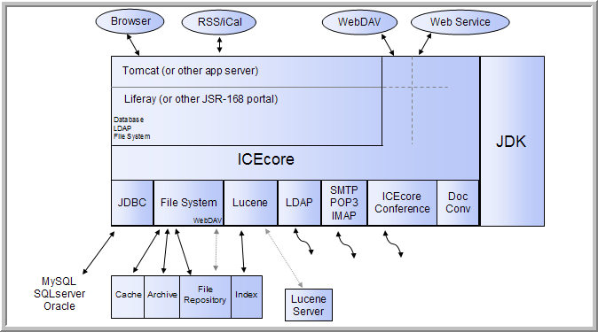

1.3 Database Planning
ICEcore and Liferay use separate dedicated databases within your database server. A set of SQL configuration scripts are used to initialize the databases (creating the necessary tables, etc.).
ICEcore’s default database for Linux and Windows is MySQL. It also supports SQL Server on Windows, and Oracle on Linux and Windows.
ICEcore’s database requirements are relatively modest. The bulk of the data uploaded to ICEcore is stored in a file repository (see File System Planning - the database is primarily used for storing metadata and descriptive text.
Because the amount of data stored in the database is highly sensitive to the usage patterns of ICEcore (which are highly variable) there is no reliable formula for determining disk space usage, but the following can be used as a guideline:
- numberAttachments x averageAttachmentSize = totalAttachmentSpace
- totalAttachmentSpace * .04 = sqlDataSpace
- sqlDataSpace x 5 = sqlStorageSapce

MySQL
- MySQL 5.0.37 (or higher) Server and Client for Linux or MySQL 5.0.26 (or higher) Server and Client for Windows are required with “innodb support” enabled
NOTE:MySQL 5.1 is not yet supported.
- Specify root for the administrator password (or make commensurate changes in the ICEcore installer.xml file)
- Set the default character set to UTF-8 by selecting “ Best support for Multilingualism” in the Windows Configuration window, or edit the my.cnf configuration file to the following:

- [mysqld]

- character_set_server = utf8

- [client]

- default_character_set = utf8
NOTE:This file is usually located in /etc/my.cnf for Linux and in c:\my.cnf for Windows, see the MySQL documentation for details.

Microsoft SQL Server
- You can use SQL Server 2000 or SQL Server 2005
- Make sure to select SQL Server and Windows for authentication (the default is Windows only)
- Set the administrator password to “ sa” (or make commensurate changes in the ICEcore installer.xml file)

Oracle Database
- Supported versions: Oracle 9, Oracle 10.
NOTE:Oracle’s default database name is “orcl”. We use this name in our examples. If you have chosen a different name, replace “orcl” with your database name.
- ICEcore is a Unicode-enabled application and requires you to set up the Oracle Database Character Set to support Unicode character encodings. ICEcore requires either the UTF8 or AL32UTF8 character set for proper operation. Oracle recommends the use of AL32UTF8 as it has increased support for certain Asian languages. Consult your Oracle documentation for the choice that makes sense for your database.
- To check your database character set, execute the following command with SQL*Plus:

- select value from SYS.NLS_DATABASE_PARAMETERS where PARAMETER = 'NLS_CHARACTERSET';
- Before you install the ICEcore application software, use the “Create Initial Database Scripts” option of the installer to create the two database creation scripts for Oracle; one for the portal and one for ICEcore. Although other scripts are also created under C:\icecore\dbcreationscripts you want the following two scripts:

- \icecore\create\create-database-oracle.sql

- \liferay\create\create-oracle.sql
  - These two scripts need to be accessible to the SQL*Plus utility and your database, so copy them to a location on your system PATH.
  - Edit the supplied database scripts to set the passwords for the users (these are defined in the top few lines of each script).
  - Use the SQL*Plus utility with the SYSTEM account to run the scripts:

  - sqlplus SYSTEM/systemPassword @create-oracle.sql

  - sqlplus SYSTEM/systemPassword @create-database-oracle.sql

  - sqlplus> quit
  - Edit the installer.xml file to use the Oracle_Default configuration and change the JDBC URLs to reflect the database and username/passwords you have chosen.
For example, in create-database-oracle.sql, you see:

drop user sitescape cascade;

create user sitescape identified by sitescape;

grant connect, resource to sitescape;

connect sitescape/sitescape;
    - “ user sitescape” indicates that “ sitescape” is the name of the database created – do not change this
    - “ identified by sitescape” declares that “ sitescape” is the password for this database – change this to the password you intend to use as in “ identified by <yourpassword>” and change the “ connect sitescape/sitescape” to “ connect sitescape/<yourpassword>”
  - Install the ICEcore software using the UPDATE option (not the FULL INSTALL option). This installs the software, but does not run the database creation scripts, which you have already run separately.

Non-Local Database Setup
When installing the ICEcore software for the first time (the “FULL INSTALL” option) one of the steps involves creating two databases: one for the portal and one for the ICEcore application. If you have granted the database user specified in the configuration the privileges needed to create a database, the installer creates the databases during the installation process. For example, in MySql you can first create the databases and grant full access to the database user specified in the installer.
If this is done, the installer can create the rest of the database schema without further intervention:

create database lportal;

grant all on lportal.* to dbuser@host identified by 'dbpassword';

create database sitescape;

grant all on sitescape.* to dbuser@host identified by 'dbpassword';
However, there may be a number of reasons why this is not desirable. If your database server administration does not allow this for security reasons, or if you have a special database setup, the installer can initially be run to extract the schema setup files and place them on the disk for you to examine or forward to the database administrator. Once the schema is in place and the database user has been given the appropriate access rights for full database access, the installer can be run with the UPDATE option, which installs the software but does not create the databases.
The following are “generic” database rights needed for normal operation of ICEcore:

DELETE, INSERT, SELECT,UPDATE,

ALTER TABLE, CREATE TABLE, CREATE VIEW, DROP,

CREATE INDEX, DROP INDEX, DRI
The first four are obvious. The rest are related to schema changes that may be invoked during upgrades or configuration changes.
NOTE:“DRI” refers to Microsoft SQLServer foreign key constraints.
The initial database creation scripts may CREATE/DROP USERs, but that is the only time users are defined.

1.4 File System Planning
ICEcore software and configuration files are stored in a tree shared with Liferay, Tomcat, etc. There are some temporary files also located here, but mainly locks, etc.
ICEcore data is stored in the database (see Database Planning) and on the file system. The file system usage is divided up into several functional areas:
- filerepository - This is where all attachment files are located, so it is a large consumer of disk space. The tree is roughly organized by site, binder (folder/workspace), and entry.
- archiveStore - Only activated in the Enterprise version of ICEcore, this is where previous file versions are stored to meet compliance and archival goals.
- cachefilestore - This tree holds information derived from the attachments, such as thumbnails, scaled images, text, and HTML renderings. Depending on the nature of the attachments this tree consumes somewhat less space than the file repository (but it can, conceivably, store more).
- lucene - This tree holds the search index for the data. It tends to be a fraction of the space consumed by the file repository, but it is also sensitive to the type of information stored.
- Other trees - These are other trees that you cannot configure, which typically only consume a small amount of space (relatively speaking).

  - rss - Caches of RSS feeds for folders
  - temp - Temporary files

1.5 Network Planning
ICEcore is a complete Java/J2EE web application and includes a web server (Tomcat). Because the web server listens on ports and processes network connections, you should consider the following as part of the installation process:
Firewall Setup - The default installation uses port 8080/8443 for the web server. Some local firewalls (such as the Windows Security Center’s firewall) may restrict traffic to port 8080/8443 and thus require proper configuration for access by other systems.
If you can access ICEcore on the local server, but cannot access it from another system, examine your firewall settings.
Port Conflicts - The Tomcat software uses a number of TCP/IP ports for both web traffic and management messages. If you have other web servers (Apache, IIS, or Tomcat) or other software installed that uses the same port numbers, your ICEcore software will not function properly.
NOTE:Novell OES2 systems have another Tomcat application running by default.
The netstat -anp tcp command on Windows and the netstat -tan command on Linux can help find which ports are currently being used. For more information on network ports, consult your operating system networking guide.
When you are in this situation, make sure that in addition to the http/https ports (8080/8443) you also assign free port numbers to the ajpPort and shutdownPort settings in the Network section of the installer.xml file.
Port Mapping - For instances where the port number on which Tomcat listens for connections is different than what the end-user sees in their browser, change the listenPort and secureListenPort settings to the local server ports and set the port and securePort settings to the port numbers that the browsers are using. See Port 80/443 configuration on Linux and Integrating with iChain for details.
The host, port and securePort settings are used to generate URLs within the product and so must match what the user’s browser sees. Unless overridden by the listenPort and secureListenPort settings, the port and securePort settings are used as the server’s listen ports.
Liferay Session Timeout - You can configure ICEcore to log out of a session after a certain number of minutes. The default is 2 hours (240 minutes). You can change this by altering the sessionTimeoutMinutes attribute of the Network/Liferay setting.

1.5.1 Port 80/443 configuration on Linux
The default installation of ICEcore uses the Tomcat web server. Although the Tomcat server is part of the Apache project, it is not the same thing as the Apache web server. Tomcat is written in Java and can not perform some of the special privilege behaviors that Apache can.
In particular, Linux does not allow non-root processes from allocating TCP/IP ports less than 1024. For this reason the default configuration for Tomcat (and ICEcore) uses ports 8080 for http and 8443 for https (SSL). Unfortunately this requires specifying the port number in the browser's URL for ICEcore (e.g., http://icecore.mycompany.com:8080).
WARNING:While running Tomcat as “root” solves this problem, it creates many (far worse) problems. Do not do this!
If you want ICEcore to be available on the default http/https ports, use an operating system feature called “kernal space port forwarding.” The iptables command is used to map requests from port 80 to port 8080 (or whatever port you specify). For example:

iptables -t nat -A OUTPUT -d localhost -p tcp --dport 80 -j REDIRECT --to-ports 8080

iptables -t nat -A OUTPUT -d yourHostname -p tcp --dport 80 -j REDIRECT --to-ports 8080

iptables -t nat -A PREROUTING -d yourHostname -p tcp --dport 80 -j REDIRECT --to-ports 8080

iptables -t nat -A OUTPUT -d localhost -p tcp --dport 443 -j REDIRECT --to-ports 8443

iptables -t nat -A OUTPUT -d yourHostname -p tcp --dport 443 -j REDIRECT --to-ports 8443

iptables -t nat -A PREROUTING -d yourHostname -p tcp --dport 443 -j REDIRECT --to-ports 8443
Note that these changes only affect the running system. You need to add them to your startup sequence. See the *iptables* and *iptables_save* man pages for more information about setting up port forwarding.
When using this type of configuration you must explicitly specify the ports the Tomcat server listens to and the ports that the browsers see separately in the Network section of the installer.xml.
For example:

port="80" listenPort="8080"

securePort="443" secureListenPort="8443"

1.5.2 Integrating with iChain
NOTE:This feature is only available in the Enterprise version.
Liferay/ICEcore contains support for iChain-based single sign-on (SSO). When running in this mode, the iChain server performs user authentication tasks and passes a token representing the authenticated user’s login name to Liferay/ICEcore in each request to indicate who made the request.
You must configure Liferay/ICEcore with the same LDAP that the iChain is using so that it can obtain and copy the user information into the portal. However, this configuration differs from the regular portal/LDAP integration in that no password checking is performed against the LDAP when logging into the portal (because credential checking is only performed by the iChain server). This technique is safe only under the assumption that ALL accesses to the portal are routed through the iChain proxy.
The SSO configuration sets up a “valve” that only permits access from the local server and the iChain proxy server. For more information about Tomcat’s valve configuration, see tomcat.apache.org.

To set up an iChain proxy, the following steps must be taken:
- Assure that the iChain proxy’s host name and port number match the ICEcore/Liferay port number. For example, if you have configured ICEcore to run on port 8080, the iChain proxy should also use port 8080. If the port numbers differ you must use the “listenPort” option in the ICEcore Network configuration.
For example if the iChain is set to provide access on the default ports (80/443) while Tomcat is listening on ports 8080/8443, set the configuration to:

name="your.server.host.name"

port="80" listenPort="8080"

securePort="443" secureListenPort="8443"
WARNING:If the iChain proxy and ICEcore host names/ports are not set up identically, you may experience page layout issues and other ICEcore features may not function properly.
- Edit the SSO section in the installer.xml file and set the SSO enable="true", set the Logoff URL to the log-off URL provided by the iChain proxy server, and set the IP address of the iChain proxy server.
- Install the software or, if you have already installed ICEcore, stop the running server and use the installer’s “ Apply Settings only” option.
- After enabling the iChain SSO, you need to log into Liferay using a direct login URL: http://localhost:8080/c/portal/login and log in as admin. Since the SSO configuration removes the “ Sign In” link, you must type the URL manually.
- If you have not already done this, use Liferay’s Admin portlet to enable LDAP-based authentication. This setup is necessary since Liferay has to copy user data from the LDAP into the portal database upon user login.
- To prevent users from logging into the portal directly through the portal’s login form, remove or rename the following file from ICEcore’s liferay-portal-tomcat directory:

- webapps/ROOT/html/portal/login.jsp
You may also need to remove:

work/Catalina/localhost/_/org/apache/jsp/html/portal/login_jsp.*
- Liferay/ICEcore is now ready to be put behind the proxy. Consult your iChain documentation on how to do this.
To enable iChain integration-related debug log messages, modify Liferay’s portal-log4j-ext.xml to add the following category:

<category name="com.sitescape.team.liferay.security.auth">

<priority value="DEBUG" />

</category>
Use it only for testing or troubleshooting purpose. It is not recommended to have debug logging enabled on a production system.

1.6 Editing the Installer (.xml) File
The installer.xml file provides the ICEcore installer with detailed configuration information regarding network, memory, database, file system, e-mail, presence, and other settings. Edit this file with your specific data.
The “ sample-installer.xml” file is included in the kit and should be used as a template for the installer.xml file. If you are doing an upgrade, use your existing installer.xml file by placing it in the same directory as the installer program. If you are doing a new installation, copy the sample-installer.xml file to installer.xml and edit that file.

For a quick installation edit the following sections:
- Change the Host name in the Network section. Change the port number to 80 and the securePort to 443 if this is a dedicated server.
- Consider changing the JavaVirtualMachine setting in the Memory section if you have a large installation.
- Use the default file system configuration. This stores the files in /home/icecoredata
- The default database configuration is MySQL, with the default MySQL passwords.
- Use the default Lucene configuration (unless you are installing a standalone Lucene Index Server.
- Modify the Email section with your SMTP and POP/IMAP servers.
- If you are using ICEcore Conference, change the settings in the Presence configuration.
To view the sample-installer.xml file, see Section A.0, The sample-installer.xml File.

1.7 Running the Installer
The following procedure shows you how to run the installer.
- Run the installer (on Linux, do a chmod +x installer-liferay.linux to make the installer executable).
The installer is named one of the following according to your operating system and portal server:
  - installer-liferay.exe
  - installer-liferay.linux
- Answer Yes to the license agreement:

- Have you read and agree with the license? : yes
- Enter the type of install you are performing:
WARNING:A full install erases the existing databases for an existing ICEcore application (use the UPDATE installation for existing ICEcore applications).

Enter the type of installation:

1. ICEcore Enterprise with Liferay/Tomcat - FULL INSTALL

2. ICEcore Enterprise with Liferay/Tomcat - UPDATE

3. ICEcore Enterprise Lucene Server

4. Apply settings only (Use with care)

5. Create Initial Database setup scripts for DBA

6. Exit (no changes)

Installation type [1]: 1

  - FULL INSTALL - This option installs the ICEcore application software and creates the initial portal and ICEcore databases.
The software is installed in the following dedicated directory: /opt/icecore
  - UPDATE - This option installs the ICEcore application software and uses the existing portal and ICEcore databases. Schema updates are applied as necessary.
  - Lucene Server - This is an advanced configuration option that allows you to locate the Lucene Index Server on a different system than your ICEcore application server. See Section 1.12, Installing a Standalone Lucene Index Server for details on configuring your systems to use this option.
  - Apply Settings - The installation program uses configuration information in the installer.xml file to write a number of application configuration files. Most changes to the configuration do not require a reinstallation of the software, but just an update of the settings. Use this option to update those files without reinstalling the software.
NOTE:The Apply settings only option can potentially corrupt your existing system (USE WITH CARE).
  - Create Initial Database Scripts - By default the software installation process creates the database schemas needed for operation of the software. If your database server administration does not allow this, use this option to extract the schema setup files for review and execution by your database administrator (DBA). This option installs no software or makes any changes to the application configuration.
- Review the installation messages and enter Y to continue the install or N to cancel:

- Enter Y to continue, enter N to cancel installation [Y]: Y
- The install process asks you if want to create the ICEcore databases at this time; select 1 to create the databases or 2 to skip this step:

- About to create the databases for ICEcore:

- 1: Create the databases now.

- 2. The databases were created by my DBA, don’t create them now.

- (1/2) [1]: 1

- Creating liferay database for SQLServer ...

1.8 Starting and Stopping ICEcore

Starting ICEcore/Liferay
NOTE:These are Liferay only instructions.
On Windows:
C:\yourinstall\liferay-portal-tomcat-5.5-jdk5-4.3.0\bin\startup.bat
On Linux:
/yourinstall/liferay-portal-tomcat-5.5-jdk5-4.3.0/bin/icecore start
NOTE:While this is dependent on your system configuration, it can take upwards of 60 seconds before ICEcore/Liferay starts accepting web transactions. Initial transactions also tend to be slower as various caches load into RAM. These delays are amplified somewhat when working with a new installation or updated software as the JSPs are recompiled as they are referenced. In Windows, startup is complete when the Tomcat window displays: INFO:Server Startup in ##### ms

Setting up ICEcore to Start on System Startup
On Windows:
- C:\yourinstall\liferay-portal-tomcat-5.5-jdk5-4.3.0\bin\service.bat install icecore
- Use the Services Control Panel to configure the service to your needs.
  - Select Control Panel > Administration Tools > Services.
  - Right-click on the ApacheTomcat icecore service and select Properties.
  - Change the Startup Type to Automatic and click OK.
  - Set your firewall to allow port 8080.
On Linux, from the root account:
- cp /yourinstall/liferay-portal-tomcat-5.5-jdk5-4.3.0/bin/icecore /etc/init.d
- chkconfig --add icecore

Log Files/Monitoring
On Windows:
A Tomcat window appears when you issue the startup.bat command. Messages (good and bad) appear here.
On Linux:
Unlike Windows, the Tomcat process starts as a background process and no window appears. To monitor the messages in real time:

tail -f /yourinstall/liferay-portal-tomcat-5.5-jdk5-4.3.0/logs/catalina.out

Stopping ICEcore
On Windows:

C:\yourinstall\liferay-portal-tomcat-5.5-jdk5-4.3.0\bin\shutdown.bat
On Linux:

/yourinstall/liferay-portal-tomcat-5.5-jdk5-4.3.0/bin/icecore stop

1.9 Memory Guidelines
ICEcore is a Java/J2EE application and therefore executes within a “Java Virtual Machine” (JVM). The JVM exists as a process on your system and all of the ICEcore and portal software runs within it. Consequently the amount of memory available to the JVM process is a critical aspect of overall ICEcore performance.
The key JVM memory setting is the “Java Heap Size,” which roughly corresponds to the amount of memory available to the Java applications (such as ICEcore).
The installer.xml file’s Memory section allows you to determine how much physical memory to devote to the Java Virtual Machine.
The default configuration assumes that the JVM uses 1g (one gigabyte) of memory. It is possible to run ICEcore with less than 1GB of assigned memory, but this is only applicable to very small test configurations, and is not suitable for production use. (In such a test configuration, 512MB is the minimum amount of memory required to produce a functioning ICEcore application.)
A general rule of thumb is that no more than 75% of the available physical memory should be allocated to the JVM. This means that you need to account for other processes (including the operating system itself) that use memory. Databases, in particular, tend to be memory-intensive, so take special care when co-locating a database server with the ICEcore application server.
Java and ICEcore make heavy use of available memory to provide good performance. Larger deployments (large numbers of users and/or large numbers of documents) often need memory settings in excess of 2GB to provide adequate performance. For these conditions, 64-bit hardware coupled with a 64-bit JVM are required.
WARNING:A JVM on a 32-bit system should never be configured to take more than 1.5GB (1500MB) of memory. Larger memory allocations require 64-bit servers.

ICEcore memory usage is driven by a number of factors:
- Number of sessions (users logged in)
- Number of active/concurrent sessions
- ICEcore internal database caches
- Lucene index cache
Items #1 and #2 do not represent a significant amount of memory.
Item #2 generally correlates to heavier CPU utilization (as this number increases the need for clustered configurations becomes more important).
Item #3 can be a significant fraction of memory use (these are separate from any caching or memory use by the database server itself, which may or may not be on the same server). Internal tuning settings have been set to handle a wide range of deployment sizes.
Item #4 can also be a significant consumer of memory. Large data stores (particularly with large files or a high number of files) can create a very large index. Installations with this type of demand should consider separating the Lucene Index Server to a dedicated standalone server for optimum performance (see Section 1.12, Installing a Standalone Lucene Index Server).

1.10 Security Guidelines
This section contains security guidelines for the following:
- Liferay Session Timeout - The default session timeout is 2 hours (240 minutes). You can lengthen or shorten this by changing the Network/Liferay sessionTimeoutMinutes setting in the installer.xml file.
- Role-Based Access Control - ICEcore controls all access to folders and entries using role-based access controls. See Section 2.6, Adjust Access Control for the Site to learn more about the default roles and access settings. Please keep in mind that ICEcore is intended to be used primarily for the sharing of information, so many default access rights lean towards allowing at least universal read access.
- Inbound E-mail - You can configure ICEcore to read e-mail and “post” those e-mail messages as entries in a folder. Because e-mail is inherently insecure there is no way to be sure that the sender is who they claim. ICEcore marks the entries posted by e-mail to alert users about their origin.
- Web Services are enabled by default - The default ICEcore installation allows authenticated access via web services. If you are not using web services, you can disable them by setting enable="false" in the Network/WebServices section of the installer.xml file.
- WebDAV Authentication - Authenticated access via WebDAV is via the Basic Authentication mechanism. Because of the weaknesses of Basic Authentication, secure (SSL) connections are recommended.
- RSS feed URLs - Because RSS readers are outside of the authentication system, the URL provided by ICEcore for an RSS feed embeds some authentication information about the user. This means that the RSS URL must be protected and not shared between users.
For this reason RSS is not recommended for use on highly sensitive data.
To disable RSS feeds, modify the RSS section of your installer.xml file to: enable="false" either during the initial installation or use the installer’s Apply Settings only option to disable it at any time after installation.
- LDAP (directory service) Proxy User - You can configure ICEcore (and the portal) to utilize information in the LDAP directory service to provide basic user account information (and group memberships). Access to the LDAP server is done via a configuration page that requires specifying a username and password to LDAP directory. This user should be created in the LDAP directory service with the minimum number of privileges needed to perform the job. In particular, all LDAP synchronization activities are one-way, so the proxy user only requires READ access to the directory. We highly advise that you configure LDAP with a secure connection (SSL).
- LDAP Directory access is unencrypted by default - See Section 2.4.4, Secure LDAP/eDirectory Setup for information about configuring ICEcore to use SSL when communicating with the LDAP directory.
- File System Repositories contains unencrypted data - See Section 1.4, File System Planning for details about how ICEcore uses the local file system for data storage. These directories contain uploaded information in various formats (both native file formats and potentially a number of rendered formats (e.g., cached HTML versions of files, thumbnails, RSS feeds, etc.) as well as archived data.
These files are managed exclusively by the ICEcore application software and the file system protections should be set to protect those directories from unauthorized access.
- Database access is unencrypted by default - Depending on your local security guidelines, you may want to encrypt the database connections between the ICEcore and Portal software and their respective databases. Please note that SSL encrypted data between the applications and database servers imposes a performance penalty due to the increased overhead of encrypting/decrypting the retrieved data.
Support for this is highly dependent on the database client drivers and JDBC connector support and how you are configuring your client and server certificates. You should check with the database vendors on how to set up SSL connections on both the client and server sides of the connection. At minimum you need to update the JDBC URLs in the Database section of the installer.xml file (e.g., for MySQL you might add “ useSSL=true&requireSSL=true” to the options part of the URL).
- Mirrored Folder Proxy User - See Section 2.10, Mirrored Folders Configuration for more information about the mirrored folder feature of the Enterprise version of ICEcore.
You can configure ICEcore to use server directories (either the local file system or via file sharing) as repositories for ICEcore folders. Because the ICEcore application server is accessing those directories, the user id that the application server runs as acts as a proxy user for all file system access (i.e., the file system only sees one user accessing the files on behalf of all ICEcore users who have access to the ICEcore folder). This proxy user should be used to configure any local file system access (or shared file access) appropriately.
If you configure a mirrored folder to a WebDAV or Microsoft Sharepoint directory, the resource driver is configured to use a proxy username and password. The same access control practices should be applied to these resources as with the file system resource driver.
- ICEcore Conference account password is stored in configuration file - If you are using ICEcore Conference, the password to a ICEcore Conference account is stored in:

- WEB-INF/classes/config/ssf.properties
- Password Storage in the Server File System - A number of application accounts and passwords are stored in the file system. These files should be protected against unauthorized access on the server.
The installer.xml file contains a majority of the account and password information. You should protect this file accordingly. The installation “Apply Setting” phase uses this information to create and/or update a number of configuration files within the application software directory tree. These files are outlined below:
  - Database user ids and passwords for the portal and ICEcore software are stored in XML files are stored in:

  - conf/Catalina/localhost/ssf.xml (ICEcore)

  - conf/Catalina/localhost/ROOT.xml (Liferay Portal)
  - Mirrored folder resource drivers to WebDAV/Sharepoint shares store the proxy user and passwords in:

  - WEB-INF/classes/config/ssf.properties
  - The e-mail access (both inbound and outbound) may contain usernames and passwords for authentication (e.g., authenticated SMTP). These are stored in:

  - conf/Catalina/localhost/ssf.xml (ICEcore)

  - conf/Catalina/localhost/ROOT.xml (Liferay Portal)
Some application accounts and passwords are stored in the database. These are protected by application access controls, but are available if access to the database is obtained through other means:
  - LDAP proxy user and password.

1.11 Document Support
When a file is uploaded into ICEcore it is processed in a number of ways:
- Textual content is extracted and sent to the search engine. For some file types (e.g., word processing documents) the textual content is obvious. For others, such as graphics files, there may be little or no textual content beyond basic metadata.
- If possible, a thumbnail (and scaled image - somewhat larger than a thumbnail) of the file is created. The thumbnail of a multi-page document shows the first page.
- If possible, a browser-only renderable (HTML) version of the file is created. This allows people who do not have the ability to open the file with its native application to get an idea of what is in the file. The rendering is on a “best effort” basis and the level of detail and fidelity of the rendering varies greatly.
The Open and Enterprise versions of ICEcore vary greatly in their ability to perform the above tasks.
The Open version uses OpenOffice to provide access to common Microsoft and OpenOffice document formats, and that is about it.
The Enterprise version uses a licensed technology from the Stellent* company (now part of Oracle*) which provides processing capabilities to a wide spectrum of file types (over 200).

Editing Support
There are two ways of editing files stored in ICEcore:
- Download the file to your desktop, edit the file and upload the file to the entry (as an attachment).
A new version of the attachment is created reflecting your changes. It is possible to manually “lock” the entry if you want to prevent other people from modifying any of the attached files.
- Certain file types provide an Edit button, which allows for “edit in place” functionality. When available, clicking on the Edit button launches a small Java applet, which (in turn) launches the associated edit program for the file. The program accesses the file stored in ICEcore through WebDAV and is subject to the individual file locking protocols that WebDAV provides. Saving the file (or exiting the application) creates a new version of the attachment - no interaction with the browser is needed.
Because the “edit in place” option requires WebDAV URL support by the application, which is not universally supported by the operating systems, you need to configure ICEcore to know which applications are “WebDAV-aware.”
The following table shows the planned default configuration of file/document support in ICEcore.
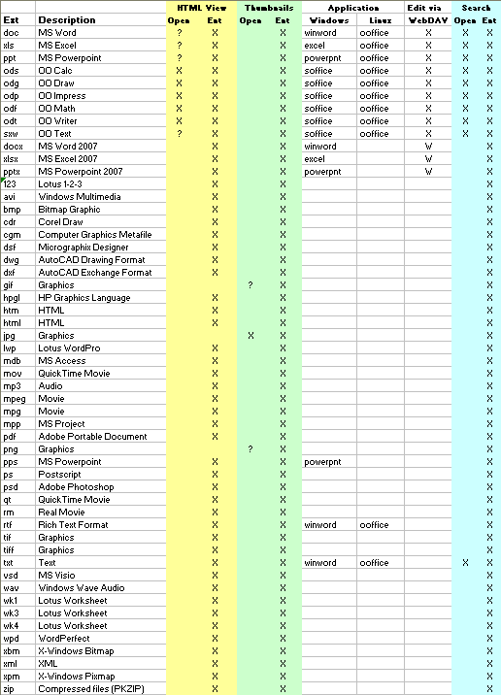

1.12 Installing a Standalone Lucene Index Server
The following procedures show you how to install the Lucene Index Server on a different machine from ICEcore (the Lucene Index Server is included in a full install of ICEcore on the ICEcore Server):
- Section 1.12.1, Install for a New ICEcore Application
- Section 1.12.2, Install for an Existing ICEcore Application
NOTE:You need to install JDK (Sun JDK 1.5.0_011 or higher) before installing the Lucene Index Server.

1.12.1 Install for a New ICEcore Application
- On the standalone machine, edit the Installer.xml file (see The sample-installer.xml File):
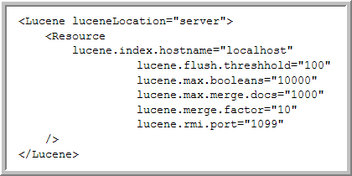
  - In the Lucene section, set luceneLocation="server"
  - If necessary, edit the default rmi port: lucene.rmi.port=“1099”
- Run the installer on the standalone machine and choose the option for: ICEcore Enterprise Lucene Server (see Section 1.7, Running the Installer).
- Start the server at the end of the installation:
  - Change directories to lucene-server-installation-dir
  - Run the rmiregistry-startup script in the bin directory
  - Run the indexserver-startup script in the bin directory
- On the ICEcore server, edit the Installer.xml file:
  - In the Lucene section set luceneLocation="server"
  - Set lucene.index.hostname to the hostname of the machine on which you installed the Lucene Index Server (in steps 1-3).
- Run the normal installation of ICEcore (see Section 1.7, Running the Installer).

1.12.2 Install for an Existing ICEcore Application
- On the standalone machine, edit the Installer.xml file (see The sample-installer.xml File):
  - In the Lucene section set luceneLocation=“server”
  - If necessary, edit the default rmi port: lucene.rmi.port=“1099”
- Run the installer on the standalone machine and choose the option for: ICEcore Enterprise Lucene Server (see Section 1.7, Running the Installer).
- Shutdown ICEcore on the ICEcore server (see Section 1.8, Starting and Stopping ICEcore).
- On the standalone machine, check the lucene-server.properties file and find the setting for index.root.dir (you can edit this setting to change the location of the root directory).
- Create a “ liferay.com” subdirectory in the <index.root.dir> directory.
- On the ICEcore server, look at the ssf.properties file and find the data.root.dir setting.
- Copy all the files from the <data.root.dir>/lucene/liferay.com directory on the ICEcore server to the <index.root.dir>/liferay.com directory you just created on the standalone machine.
IMPORTANT:If you are using ftp, make sure to copy in binary mode.
- For Unix systems, make sure permissions are set so that the ICEcore user has full access to these files and the liferay.com directory.
- Start the server at the end of the installation (if not started already):
  - Change directories to lucene-server-installation-dir
  - Run the rmiregistry-startup script in the bin directory
  - Run the indexserver-startup script in the bin directory
- Restart ICEcore (see Section 1.8, Starting and Stopping ICEcore).

1.13 Load-Balancing and Clustering ICEcore
NOTE:In this release, ICEcore does not support session replication across cluster nodes.
To set up a scalable, clustered ICEcore configuration, use the following steps as a guideline:
- Set up a shared file storage that is accessible to all nodes. ICEcore’s Simple File Repository is safe for use in a clustered environment with shared storage that is accessible to all nodes. Setting up shared storage is a platform-specific task.
- Install and configure the Lucene Index Server. See Installing a Standalone Lucene Index Server for how to place the Lucene Index Server on a dedicated server system. All cluster nodes share this index server.
- Make sure that the time is the same on all nodes in the cluster (using synchronized time services for your cluster is highly advised).
- Install the ICEcore/portal bundle kit on each cluster node.
IMPORTANT:Since all the nodes share the same database server, it is important not to execute the database-initialization SQL scripts more than once (e.g., use the installer’s UPDATE option rather than the FULL INSTALL on all but the first cluster node).
Each node in the cluster should be able to use the same installer.xml file. This assures that cluster nodes are configured uniformly.
The following settings must be uniform across the cluster:
  - Configure the database connection settings on each node to use the same database.
  - Set the file system settings to all point to the same shared file storage server.
  - Set the Network settings (e.g., name, port, etc.) to the name of the LOAD BALANCER system.
  - In the Lucene section, set luceneLocation="server" and set lucene.index.hostname to the hostname of the machine on which you installed the Lucene Index Server.
- Set the portal up to work in a clustered environment.
For Liferay, follow the instructions at wiki.liferay.com. If you are interested, Liferay provides additional high availability information at wiki.liferay.com.
- Configure the Load Balancer.
There are a variety of load balancing solutions that work with J2EE deployments. The following example configuration uses the balancer module built into the newer Apache (version 2.2.4), and is based on a widely-used sticky session technique. We do not support session sharing/replication among Tomcat instances.
  - Edit Tomcat’s server.xml.
Add jvmRoute="jvm<n>" to the <Engine name="Catalina" ...> element, where <n> should be an integer unique to each Tomcat instance. For example, assuming you have two Tomcat instances in a cluster, the Catalina engine element should look like the following in each server.xml respectively ( jvm<n> is the name of the worker as declared in the load-balancer):

<Engine name="Catalina" defaultHost="localhost" jvmRoute="jvm1">

<Engine name="Catalina" defaultHost="localhost" jvmRoute="jvm2">
  - Edit Apache’s httpd.conf file (in the <apache installation>/conf directory).
    - Uncomment the following three lines:

    - LoadModule proxy_module modules/mod_proxy.so

    - LoadModule proxy_ajp_module modules/mod_proxy_ajp.so

    - LoadModule proxy_balancer_module modules/mod_proxy_balancer.so
    - Append the following section to the end of the file:

    - <Location /balancer-manager>

    - SetHandler balancer-manager

    - Order deny,allow

    - Deny from all

    - Allow from 127.0.0.1

    - </Location>

    - <Proxy balancer://aspenCluster>

    - BalancerMember ajp://<tomcat host name 1>:8009 route=jvm1

    - BalancerMember ajp://<tomcat host name 2>:8009 route=jvm2

    - </Proxy>

    - <Location />

    - ProxyPass balancer://aspenCluster/ stickysession=JSESSIONID

    - </Location>
NOTE:In the above, you need to substitute the real tomcat host names for <tomcat host name 1> and <tomcat host name 2> respectively. If you have more than two Tomcat instances in the cluster, make an additional line for each.
- Configure Hibernate to use the cluster-safe second-level cache. For this, you need to modify the cache settings in /ssf/WEB-INF/classes/config/ehcache-hibernate.xml for each node in the cluster.
  - Uncomment the following section to enable distributed cache:

  - <!--<cacheManagerPeerProviderFactory

  - class="net.sf.ehcache.distribution.RMICacheManagerPeerProviderFactory"

  - properties="peerDiscovery=automatic,multicastGroupAddress=232.0.0.1,multicastGroupPort=4446,timeToLive=1" />

  - <cacheManagerPeerListenerFactory

  - class="net.sf.ehcache.distribution.RMICacheManagerPeerListenerFactory"

  - />-->
  - Uncomment the following section in each cache definition, including the default cache:

  - <!--<cacheEventListenerFactory

  - class="net.sf.ehcache.distribution.RMICacheReplicatorFactory" />

  - <bootstrapCacheLoaderFactory

  - class="net.sf.ehcache.distribution.RMIBootstrapCacheLoaderFactory" />-->
- Start the Lucene Index Server, and then start the application cluster nodes.

1.14 ICEcore Backup and Restore Procedures
If your system has a period of minimal activity (such as at 1:00 AM) you can do the backups without taking the system offline. If you perform this step every night, it is usually possible to restore without problems. The worst case scenario would be that the Lucene directory was caught adding an entry when the snapshot was taken. This can be remedied by re-building the search index from the ICEcore Administration portlet.

Method 1:
- Take the system down on a scheduled basis.
- During the down period:
  - Take a snapshot of the database
  - Make a backup copy of the Lucene index
  - Make a backup of the file repositories that are in use, for example:

  - /opt/icecoredata/filerepository
- Restart your ICEcore system.
NOTE:This approach is the most conservative. It guarantees a consistent snapshot of your whole system. However, doing a backup of the file repository can take a long time depending on your backup approach.

Method 2:
- Take the system down on a scheduled basis.
- During the down period:
  - Take a snapshot of the database
  - Make a backup copy of the Lucene index
- Bring the system back online.
- After the system is running again, start the backup of the file repositories.
NOTE:This approach minimizes the down time. However, it is possible that during a restore after a catastrophic failure the files may be out of synchronization with the metadata. This does cause any problems when running the system, but users may find that slightly newer versions of the files exist in the restored system than were present at the time of the database snapshot. This is usually a good thing.

2.0 Configuring ICEcore
Before using ICEcore, you need to perform initial configuration tasks to set up ICEcore so that all default features are operable. The following sections are covered in this chapter:
- Section 2.1, Log in as Liferay Site Manager
- Section 2.2, Initial Logon
- Section 2.4, Adding Users
- Section 2.5, Mail Setup
- Section 2.6, Adjust Access Control for the Site
- Section 2.7, Create Your Initial Workspaces
- Section 2.8, Invite Users to the Site
- Section 2.9, Set Up E-mail for a Workspace
- Section 2.10, Mirrored Folders Configuration

2.1 Log in as Liferay Site Manager
You need to log in using an administrator account in order to set up ICEcore for your users.

2.1.1 To Log In Using the Administrator Account:
- Type your company’s fully qualified hostname for ICEcore into the browser window and press Enter.
For example,

http://myhost

http://myhost.mycompany.com

http://somehost.foo.com:8080
The Sign In page appears.
- In the Login field, type:

- admin
- In the Password field, type:

- admin
- Click Login.
The ICEcore Home Page appears. You are now logged in as administrator.
NOTE:You need to change this password as part of the initial login.
The Liferay portal management links are in the upper-right corner of the page below the Welcome Mary Admin! text. This is the name associated with the default administration account ( administrator). When the name appears in the upper-right corner, you are logged into the system. (You can change the name Mary Admin by modifying the user profile for the administration account.)
When you begin managing ICEcore, there are only two management levels: site managers (who manage the server machine) and portal managers.
By default, administrator is the only member of the Administrators group for the Liferay portal Administrators group. Members of the Administrators group have the right to perform portal management tasks. If you choose, you can add other members to this group, so that they can help manage the portal.

2.1.2 Using the ICEcore Administration Portlet
The ICEcore Administration portlet is designed to provide you with a maximum amount of flexibility when managing resources for your teams.
Access the ICEcore management options via the ICEcore Administration portlet.

To Add the ICEcore Administration Portlet to Your Home Page:
- Click Add Content in the upper-right corner.
- In the portlet access frame that appears in the upper-left corner, click ICEcore to view the available ICEcore portlets that you can add.
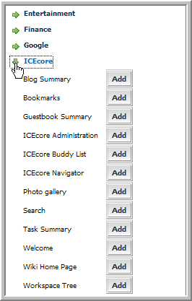
- Click the Add button next to ICEcore Administration to add this portlet to your Home Page.
The ICEcore > Administration options provides you with access to all the administration tasks controlled by the ICEcore software.
NOTE:Because ICEcore is embedded within Liferay, a portion of user management is delegated to the Liferay. For example, Liferay is responsible for all user authentications using the Enterprise Admin portlet.

2.2 Initial Logon
After installing ICEcore/Liferay you need to log in. The ICEcore installation creates one system administrator account and a default format for users.
- Access your installation with a browser via the following URL:

- http://yourhost.name.here:8080
- At the login screen enter: admin
- Enter the following Password: admin
This brings up the initial Liferay portal window.
- To add more portlets, click on the Add Content link in the upper-right-hand corner. This brings up a panel of portlets along the left-hand margin:
  - Expand the ICEcore section to add more ICEcore features, such as the ICEcore Administration portlet.
  - Expand the Admin section to add useful Liferay features such as the Admin and Enterprise Admin portlets.
The portlets are placed in the narrow column on the left side. To move a portlet to the wider right column, mouse down on the title and drag it over the right-hand column and release when you a blue bar with arrows on each side appears.

2.3 Adding You Company Logo
To add your company logo to ICEcore (upper-left corner), you need to replace the current logo in the file system under webapps for all three available themes:

...\webapps\ROOT\html\themes\Novellblue\images\teaming_logo.gif

...\webapps\ROOT\html\themes\Novellwhite\images\teaming_logo.gif

...\webapps\ROOT\html\themes\Novellgrey\images\teaming_logo.gif
NOTE:The company logo image you use should be about the same size as the current logo.

2.4 Adding Users
There are two methods of managing users:
- Basic User Management - create and manage individual accounts manually
- LDAP/eDirectory - synchronize user account management to a corporate directory
Regardless of which method you choose it is important to realize that because ICEcore is embedded within Liferay, a portion of user management is delegated to the Liferay. For example, Liferay is responsible for all user authentications.
The section includes the following topics:
- Section 2.4.1, Basic User Management
- Section 2.4.2, User Management with LDAP/eDirectory
- Section 2.4.3, The ICEcore LDAP Configuration Form
- Section 2.4.4, Secure LDAP/eDirectory Setup

2.4.1 Basic User Management
This capability comes “out of the box” with the product - no additional setup is required.
- Using the Liferay Enterprise Admin portlet, click on the Users tab.
Liferay has two portlets, Enterprise Admin and Admin. Both have Users tabs, but they do very different things. Make sure you are using the correct portlet. This brings up a list of current Liferay accounts. You can refer to the Liferay documentation for more advanced management.
- Click Add.
- Fill in the following fields: First, Last Name, assign a User ID, specify the e-mail address and click Save.
NOTE:Do not use any forbidden characters ( /\*?"<>;|) in a user’s names.
- Liferay shows an extended form.
- Click Save.
- Click on the Password tab, type in the password and click Save.
- Repeat these steps to add additional users.
The account is now ready for use, but not fully created. The administrator and other users cannot see the new user until after the user logs in for the first time. Once the new user logs in, ICEcore creates their user workspace, including a blog, calendar and file area.

2.4.2 User Management with LDAP/eDirectory
If you want to use a corporate directory as the master reference for user accounts you need to configure both Liferay and ICEcore in a similar manner. The ICEcore LDAP configuration pages are designed to look and work in a similar fashion to Liferay, easing this task significantly. You can refer to the Liferay documentation for more detailed information.
- Using the Liferay Enterprise Admin portlet, click on the Settings tab (you may need to click on the >> tab to see the Settings tab).
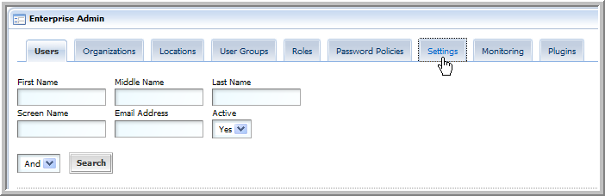
- Click on the Authentication tab.
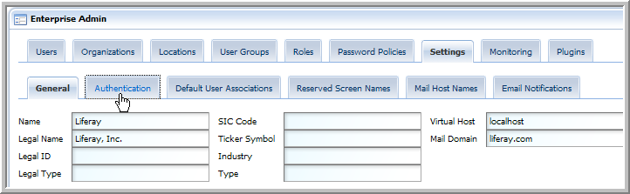
- Click on the LDAP tab.
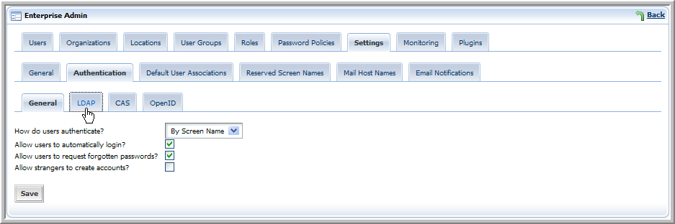
- Fill out the form with the values needed to map to your corporate directory:
  - For the search filter use uid=@screen_name@ or cn=@screen_name@, depending on your site conventions.
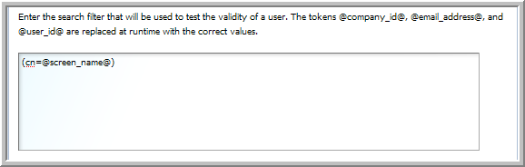
NOTE:This should be the same LDAP attribute value that you configure ICEcore with to identify the user, see Section 2.4.3, The ICEcore LDAP Configuration Form.
  - If your LDAP is set up for password comparison, select the algorithm to use for LDAP password encryption from the Encryption Algorithm drop-down list (a blank value means no encryption, MD5 and SHA specify two different algorithms).
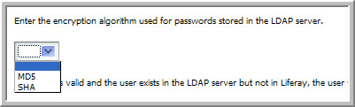
  - You need to provide your specific LDAP values for all of the listed Liferay attributes.
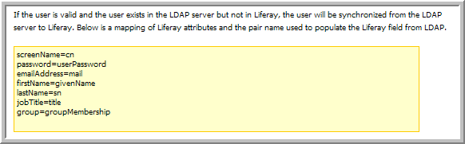
  - Under Export Settings, we recommend deselecting the Export Enabled option.
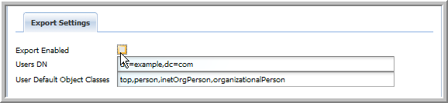
- Click Save.

2.4.3 The ICEcore LDAP Configuration Form
This form is similar to the Liferay form but includes additional information on scheduling synchronization of all users and, optionally, groups.
- Using the ICEcore > Administration portlet, click on “ Configure LDAP.”
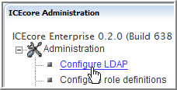
- Fill out the form using the corresponding values that were used to configure Liferay. (See below for details on this form).
- Click Apply.
NOTE:Users do not show up in the user list until after they have logged in for the first time.

Connection settings:
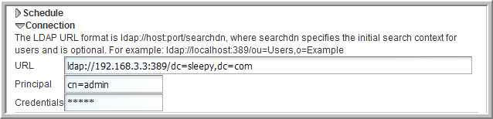
- URL: ldap://host:port/dc=foo,dc=bar, for example: ldap://192.168.3.3:389/dc=sleepy,dc=com
- Principal: LDAP principal (user) to authenticate access with, for example: cn=admin,o=itdepartment
- Credentials: Above principal’s password or authenticating token

Users settings:
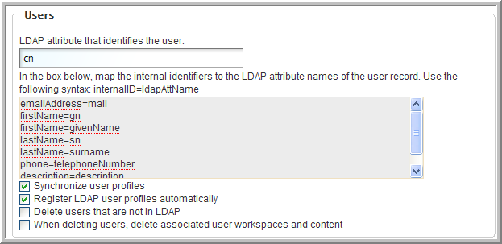
- Ldap attribute that identifies the user, for example: uid or cn
NOTE:For the LDAP attribute that identifies the user, “ cn” may be a better choice than “ uid” for many sites. This should be the same attribute value you used for the search filter in the Liferay LDAP configuration, see Section 2.4.2, User Management with LDAP/eDirectory.
- Attribute mapping - This is how you map the LDAP attribute names of the user record to the ICEcore internal identifiers. Syntax is: ICEcoreId=ldapAttName, for example:

  - lastName=sn
  - name=uid
  - ICEcoreIds: lastName, firstName, name, description, email, Address, phone
- Select Synchronize user profiles (recommended)
- Select Register LDAP user profiles automatically (recommended)
- Select others as appropriate

Groups settings:
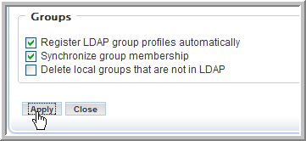
- Select Register LDAP group profiles automatically (recommended)
- Select Synchronize group membership (recommended)

2.4.4 Secure LDAP/eDirectory Setup
To connect to a secure LDAP server, you need to import the server’s certificate into ICEcore’s keystore. If the LDAP server is ldap.company.com, and it’s running on the usual ldaps port (636), then you can follow these steps using the command line interface:
NOTE:An administrator who understands the “openssl” tool should perform this procedure.
- Make sure you have openssl available.
- Type: openssl s_client -connect ldap.company.com:636
- Copy everything from the ‘ ----BEGIN CERTIFICATE----’ to the ‘ ----END CERTIFICATE----’ lines (inclusive) into a file, say cert.ldap (the name does not matter).
- From the java/bin directory type:

- keytool -import -alias ldap.company.com -keystore /sitescape-team-0.1.0/liferay-portal-tomcat-5.5-jdk5-4.3.0/conf/.keystore -file cert.ldap
NOTE:In order for this command to succeed the java/bin directory must be in the PATH variable, or the command must be launched from the java/bin directory, for example:

/usr/java/jdk1.5.0_12/bin/keytool -import -alias ldap.company.com -keystore /sitescape-team-0.1.0/liferay-portal-tomcat-5.5-jdk5-4.3.0/conf/.keystore -file cert.ldap
- If prompted for a password, the keystore’s default password is: changeit
- Restart Tomcat.
NOTE:This technique only works for real certificates. If the LDAP server is using a self-signed certificate, you also need to get the certificate for the “fake” CA and add it to the cacerts file on the ICEcore machine. The code at http://blogs.sun.com/andreas/entry/no_more_unable_to_find to get the other certificate appears to be a good example.
- Make sure you use ldaps://ldap.company.com:636 as the LDAP URL, rather than the default ldap://ldap.company.com:389 (note protocol and port number changes).

2.5 Mail Setup
ICEcore e-mail integration is divided into two primary functions:
- Notification - e-mail messages generated by ICEcore to inform people of events (e.g., new entries, changes) occurring within a ICEcore folder.
- Posting - the processing of e-mail messages sent to ICEcore with the intent of having the e-mail content added to a particular folder (as a new entry or reply).
NOTE:E-mail notification and/or postings only work with ICEcore folders. You cannot associate e-mail settings for ICEcore workspaces.

System Configuration
As part of installing and configuring ICEcore, the system administrator must supply information so that ICEcore can access the mail system (e-mail integration is not required). You can configure the level of e-mail integration you want to use with ICEcore.
The installer.xml file contains sections on e-mail configuration for both notification (Outbound) and posting (Inbound) e-mail communication. Outbound configuration requires the basic information for generating SMTP mail messages: server, port and optional authentication information.
The mail.smtp.user attribute is the address used for any e-mail notifications generated by the system. This name is also used for authenticated access to the SMTP server. To support e-mail sent by users, either the ICEcore server or the authenticated user must be authorized to use different “From” addresses.
ICEcore posting uses “real” or “alias” e-mail addresses in your folders according to how you configure your inbound e-mail settings in the installer.xml file. This is controlled by the useAliases attribute value (“false” to use real e-mail addresses or “true” to use aliases). This attribute is in the “Inbound” header line under the “EmailSettings” section:

<Inbound useAliases="false">

Using Aliases
When you use aliases for posting. the system accesses a single e-mail account (sometimes referred to as the “posting account”). Multiple e-mail addresses (aliases) can be mapped to this account and ICEcore periodically reads e-mail sent to this account and forwards the messages to individual folders according to the alias e-mail addresses assigned to them. Each folder needs a unique alias for the ICEcore posting feature to work correctly.
Create the posting account using your normal e-mail system management tools. You can configure the posting account to use either POP3 or IMAP. ICEcore needs a host, port, e-mail account id, and password for the posting feature to work.

Using Real E-mail Addresses
When you use real e-mail addresses for each folder you want to post in, you need to create multiple posting accounts using your normal e-mail system management tools. You can configure the posting accounts to use either POP3 or IMAP. ICEcore needs a host, port, e-mail account id, and password for the posting feature to work. You can only use a specific posting e-mail address for a single folder if you want the ICEcore posting feature to work correctly.

Setting up Incoming Mail schedule
- In the ICEcore Administration portlet, click on the Configure site incoming email schedule link.
- Select the Enable incoming mail option.
- Select the type of schedule you want to use for checking the posting e-mail account(s). You can configure the schedule for a specific time of the day or a regular frequency.
- Click Apply to save your changes.
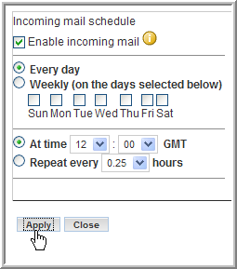
The right-hand side of the setup page lists any e-mail addresses and the folders that are using those addresses. You set up the e-mail address to folder mapping within the folders themselves (see next section).

Associating an E-mail Address with a Folder
If you enable incoming e-mail, the final step that you need to take is to associate a particular e-mail address with a folder. When this is done, e-mail sent to that address is “read” by the folder and turned into entries (or replies).
- Navigate to the folder where you want to post e-mail and select the Manage > Email settings menu item.
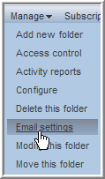
- Enter the e-mail address you want to associate with this folder in the Receive email from this address (incoming): field.
- If you using real e-mail addresses, enter the password for this e-mail address in the Password field.
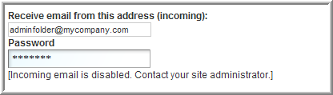
- Click Apply to save the address.
You can optionally set up the notification schedule for this folder at the same time (see next section).

Establishing a Notification Schedule for a Folder
You can configure each folder to send out e-mail messages highlighting activity within the folder.
- Navigate to the folder where you want to post e-mail and select the Manage > Email settings menu item.
- Select the Enable outgoing email option.
- Select the type of schedule you want for notification. You can configure the schedule for a specific time of the day or a regular frequency.
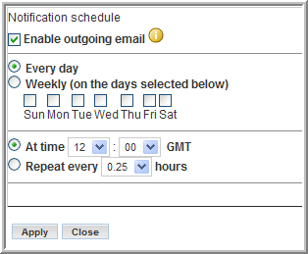
- You also need to specify who is to receive the e-mail. This can be a combination of users, groups, and arbitrary e-mail addresses.
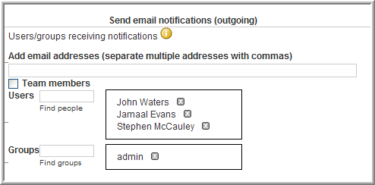
- Click Apply to save the schedule.

2.6 Adjust Access Control for the Site
One of your first tasks as a site manager is to set the access roles to control how different users can view and participate in the site workspaces according to what access role they are assigned. All Access Roles are assigned to users in individual workspaces or folders, except for the Site Administration access role, which grants access to the whole site. There are specific Role Definitions that you can edit to accomplish this. See the default Role Definitions below.

Key Ideas to Keep in Mind:
- Understand the default access control settings and the philosophy behind them (quick team formation, open communications, etc.)
- Determine the values and needs of your organization and adjust the access control settings accordingly
- The best way to delegate administrative tasks is to create groups and use the access-control tools to delegate folder and workspace administration accordingly

2.6.1 Default Role Definitions
The following are the default Role Definitions, which should be more than enough to configure your site, though your site administrator can add new Role Definitions if required.
- Workspace and Folder Administrator
Assigns every access right, but Site Administration, to users for the specific workspaces and folders that they administer.
- Participant
Assigns the following default access rights to users for any workspaces or folders in which they are participants:
  - Add Comments
  - Create Entries
  - Delete His or Her Own Entries
  - Modify His or Her Own Entries
  - Read Entries
- Site Administrator
Has every access right selected by default. These rights apply to every workspace and folder.
- Team Member
Assigns the following default access rights to users for any workspaces or folders in which they are team members:
  - Add Comments
  - Add Folders
  - Add Workspaces
  - Create Entries
  - Delete Entries
  - Delete His or Her Own Entries
  - Generate Reports
  - Manage Community Tags
  - Modify Entries
  - Modify His or Her Own Entries
  - Read Entries
- Visitor
Assigns the following default access rights to users for workspaces or folders in which they are visitors:
  - Add Comments
  - Read Entries
- Workspace Creator
This Role Definition is a special definition assigned to All Users at the Top Team Workspace to give every user the right to create a new Team Workspace. The Site Administrator can edit the Top Team Workspace access rights so that only specific users can add Team Workspaces, see Section 2.6.3, Edit Default Team Workspace Access Rights.

2.6.2 To Change a Default Role Definition:
For example, you may choose to prevent visitors from adding comments in the site.
- In the ICEcore > Administration portlet, click Configure Role Definitions.
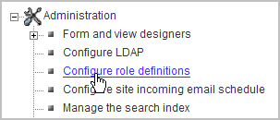
The Configure Roles page appears.
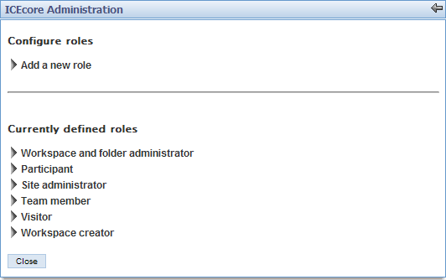
- Click Visitor.
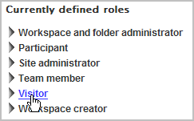
- Under Visitor, deselect the Add Comments option, and then click Apply.
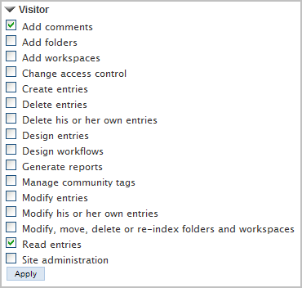
- Click Close to return to your Home Page.
Visitors to your site can now view entries, but can no longer add comments.

2.6.3 Edit Default Team Workspace Access Rights
Every workspace and folder has their own access rights. Access rights are the assignment of the Role Definitions to groups and individuals for a workspace or folder. When you create a new workspace, it starts off with the default access rights according to the type of workspace you created: Global, Personal, or Team.
NOTE:A personal workspace is created when a user signs into ICEcore for the first time.
The Site Administrator can edit these default settings, for example, you might want to edit the Top Team Workspace access rights so that only specific users or groups can add Team Workspaces.
First you want to create a Team Creator group to be in charge of Team Workspace creation, and then you want to remove the Workspace Creator Role Definition from All Users and assign it to the Team Creator group in the Top Team Workspace access rights. The site administrator can add new users to the Team Creator group at any time.

Create the Team Creator Group:
- In the ICEcore > Administration portlet, click Manage Groups.
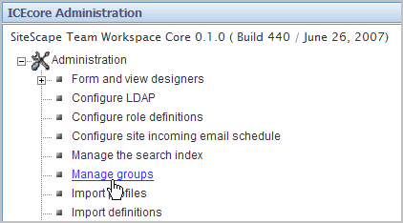
- In the Manage Groups window, click Add a New Group.
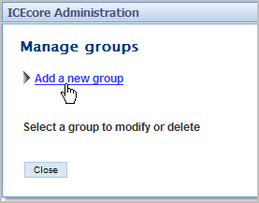
- Enter the new group’s name, title, description, and then click Add.
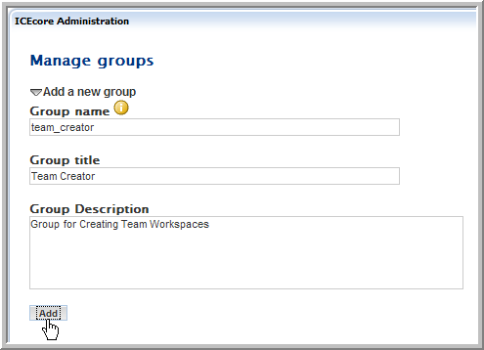
The new group appears on the page.
- Under Select a Group to Modify or Delete, click the Team Creator (Team Creator) group.
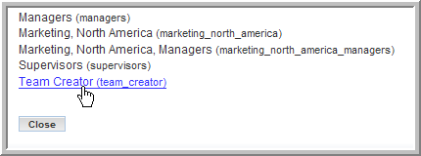
- Add users to the group and click Apply.
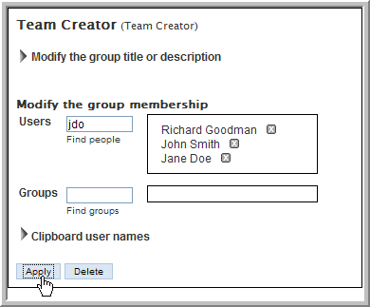
- Click Close.
NOTE:See the Online Help or ICEcore User Guide for details on adding users to groups.

Grant the Team Creator Group Sole Team Workspace Creation Rights:
- Click Team Workspace.
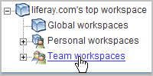
- Select the Manage > Access Control menu item.
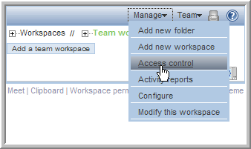
The Configure Access Control page appears. This page allows you to assign the Role Definitions to specific groups and users from the workspaces and folders. The current page controls the access rights for the Top Team Workspace area.
- Click Add a Group in the Access Rights table.
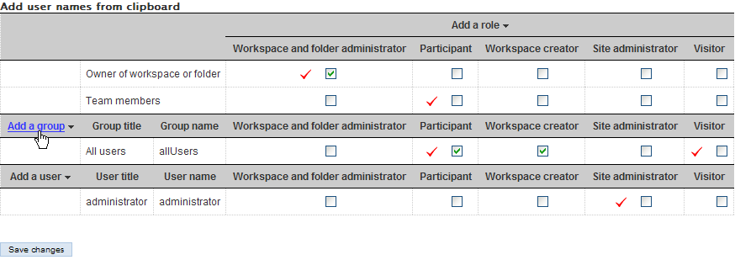
- Start typing Team Creator in the Add a Group dialog that appears and select Team Creator from the drop-down list that appears.
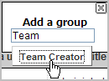
The Team Creator groups appears in the Access Rights table.
- Deselect the Workspace Creator option for the All Users group and select the same right for the Team Creator group.
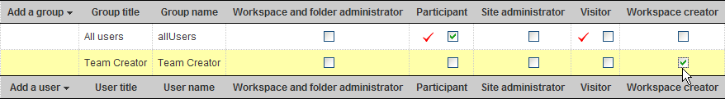
- Click Save Changes.
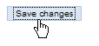
- Click Close.
You have now created a specific group to control the creation of Team Workspaces. This is an example of how you use Role Definitions and access rights to configure your site. You want to map out the access issues for your site so you can edit the default Role Definitions and default access rights for your workspaces prior to granting all your users access to the site.

2.7 Create Your Initial Workspaces
There are three types of workspaces in ICEcore: Global Workspaces (company wide), Personal Workspaces (individual), and Team Workspaces (smaller teams). Once a new workspace is created, every sub-workspace and sub-folder inherits its access rights from the parent workspace by default. The workspace or folder administrator can de-select this option for any individual sub-workspace and sub-folder (on the Access Control page for the individual workspace or folder).
Planning the initial content for your site is an important step in regards to how your users learn and use the site. Without some content, users are lost. However, too much content (especially empty containers and a complex structure) might cause users to have trouble mapping to the real work they have to do. So, before letting end users into the installation, the Global Workspace should have enough content to engage them, but not so much as to overwhelm them. Also, we have seen time and again that a workspace hierarchy and set of dedicated applications are best developed in parallel with users using the product and providing feedback about what best serves their needs.
The best approach is to plan out a tight minimal set of content in the Global Workspace to provide the end users with a functional site that they can quickly navigate and start using.

Creating Teams
The team creation process can be simplified with some up front planning:
- Although, by default, anyone can create a team (unless you edit the default access rights, see Section 2.6.3, Edit Default Team Workspace Access Rights) the process is a lot easier if a site administrator creates group names for teams before team creation occurs.
- Thinking through how you want to architect group names is a useful up front task.
- Access control is greatly simplified and enhanced by utilizing well-planned group names for your site.

2.7.1 Create an Administration Team Workspace
NOTE:You should create an Administration group first to simplify the process for editing your administration access rights. You can then add this group to the administration team and set the access rights to this group. In the future, you can add or delete users from this administration group and not worry about editing the administration team’s access rights for individual members since they are assigned correctly to the group. Assume the admin group now exists.
- From your Home Page, click Team Workspaces.
- Click Add a Team Workspace.
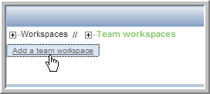
- Type in a Workspace Title for the new workspace.
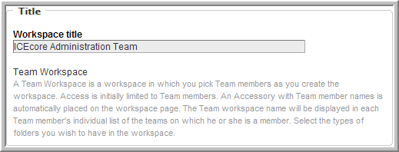
- Select the team members (add the admin group, which we will also use for setting access rights so that you only have to control membership to this group to control administrative access rights and administration workspace membership).
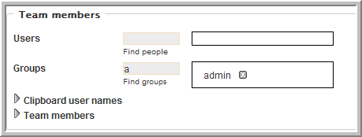
NOTE:See the Online Help or the ICEcore User Guide for details on selecting users.
- Select all the initial Workspace Folders you want to create in this workspace.
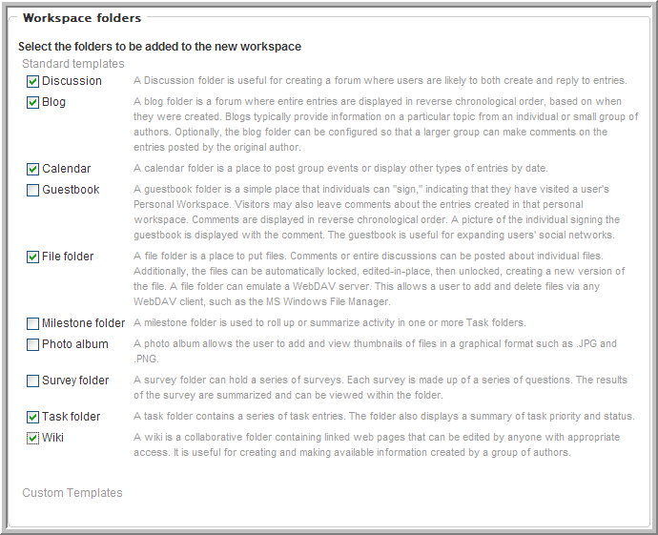
- Click OK.

2.7.2 Set the Administration Team Access Rights
- From the ICEcore Administration Team workspace, select the Manage > Access Control menu item.
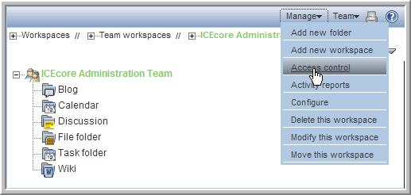
- In the Access Rights table, click Add a Group.
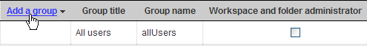
- Start typing in admin, and select admin from the drop-down list that appears.
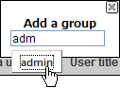
- For the admin group, select the Workspace and Folder Administrator, Participant, and Team Member roles.
- Click Save Changes.
- Click Close.

2.7.3 Using the Root Team Workspace
You can set any workspace to be a “root” team workspace, which allows anyone with the correct access rights to add workspaces under the “root” workspace. A “root” team workspace has the Add a team workspace button available to anyone with the appropriate access rights.
An administrator can set a workspace to be a “root” team workspace temporarily, while the sub-workspaces your company needs to set up are added, or permanently so that users can create additional workspaces under the “root” team workspace on a continuous bases. How you configure a specific area depends on what the workspaces are used for and how much control you want the users to have over the layout of the site.

Configuring a Workspace to be a Root Team Workspace:
- From the ICEcore Administration Team workspace, select the Manage > Configure menu item.
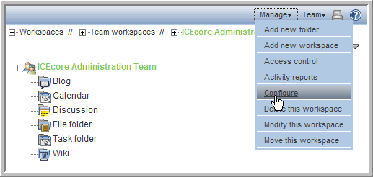
- Select the Team workspace root option and click Apply.
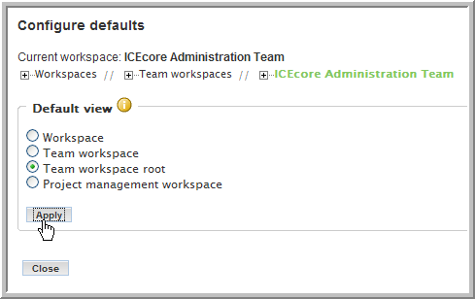
NOTE:For a regular workspace, select the default Workspace view. If you want to track project tasks and milestones based on task completion, select the Project management workspace view. For a team workspace, select the Team workspace root view to display the Add a team workspace button. If your team workspace is organizational in nature and not intended to have team workspaces as its subworkspaces, select the Team workspace view, which omits the Add a team workspace button.
- Click Close.
The Add a team workspace button is now available in the ICEcore Administration Team workspace.
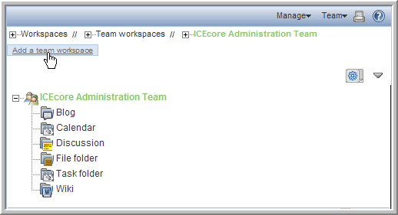
NOTE:Since only members (administrators) of the admin group have access to this workspace, you can make it a permanent Team workspace root, so any administrator can create sub-workspaces.

2.8 Invite Users to the Site
Most end users require some minimal guidance before entering the site. They need to be invited (there is no automatic way to do this, unless you invite them during team creation (ICEcore is designed to be team-centric). The invitation should contain the URL to the site. Also, you may want to include the ICEcore Quick Start Guide and ICEcore User Guide in the e-mail invitation.
Your organization may want to run some training sessions before having people enter the site.

2.9 Set Up E-mail for a Workspace
To set up notifications in a workspace, first enable them on one of the top level folders in your workspace. Once this is done, e-mail notifications are enabled on all sub-folders. For postings, you need to configure the workspace with a valid e-mail address. See your e-mail administrator to get a valid e-mail address for your workspace. See Section 2.5, Mail Setup for information on configuring the ICEcore e-mail features.
- From your workspace, select the top level folder for which you want to enable e-mail.
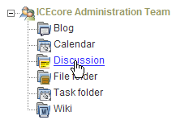
- Select the Manage > Email Settings menu item.
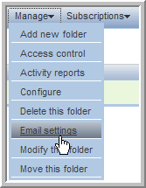
- Type in the e-mail address you received from your e-mail administrator in the Receiving Email From field.
This enables the folder to receive e-mail posts.
- Configure the e-mail Notification Schedule and add the users, groups, and any individual e-mail addresses you want to receive e-mail notifications and click Apply.
NOTE:See the Online Help and the ICEcore User Guide for more details.

2.10 Mirrored Folders Configuration
NOTE:Mirrored Folders are available in the Enterprise Edition only.
A mirrored folder is an ICEcore folder that uses a server file system directory as its file storage area instead of the normal ICEcore repository. Typically the directory is a “file share”, accessed via normal file sharing mechanisms. ICEcore attempts to keep its knowledge about the folder contents in sync with whatever is in the directory.
Because of the way mirrored folders are configured, they are intended to bring common (relatively static) file shares into the ICEcore environment – they are not appropriate for individual file shares. You can then use ICEcore to add additional metadata around these files, including ICEcore-specific access controls.
Specify the server directories that you need to make available to ICEcore in the server configuration files. The installer.xml has a section devoted to specifying mirrored folder resource drivers. These drivers then make the files in the specified directory available to the ICEcore folder(s). It is important to note that the ICEcore process accesses the directories and that the user id ICEcore runs as acts as a proxy for all ICEcore users.

To Create a Mirrored Folder:
- Add a “MirroredFolder” section to the installer.xml file. This creates a Mirrored Folder Resource Driver. (You may want to use one of the disabled samples as a template.)
Remember to set the “enabled” attribute to “true” and specify a unique id, title, the path to the directory to share and the users and/or groups that can utilize this resource. To prevent accidental modifications to the file share, set the “readonly” attribute to “true”.After updating your installer.xml file, you need to run the ICEcore installer with the Apply settings only option, and then restart ICEcore to create the resource drivers.
- Log into ICEcore as one of the users you specified in the mirrored folder resource driver (or as a member of one of the specified groups).
- Create a custom entry type representing mirrored files:
  - Go to ICEcore Administration portlet > Form and view designers > Entry designer.
  - Click Entry definitions.
  - In the dialog on the right, click Add a new entry definition.
  - Type in a Caption (e.g., Mirrored File entry) and Name (e.g., Mirrored File entry), and then click OK.
  - Expand Entry form definition and click Form.
  - In the dialog on the right, click Add.
  - In the Standard form elements dialog on the right, click File upload.
  - Type in a Caption (e.g., Mirrored File) and Name (database name, e.g., mirrored_file), select External Resource Adapter (Mirrored folder only) from the Repository system drop-down list, select the Required option, and then click OK.
  - Under Entry form definition > Form, click Attachments - Attachments.
  - In the dialog on the right, click Modify.
  - Select External Resource Adapter (Mirrored folder only) from the Repository system drop-down list, and then click OK.
  - Click Entry view definition.
  - In the dialog on the right, click Add.
  - In the Standard form elements dialog on the right, click the name of the element you just defined ( Mirrored File).
  - In the dialog on the right, click OK.
  - Exit the ICEcore Administration portlet.
- In ICEcore, create a folder of type File folder.
- Within the folder, select the Manage > Modify this folder menu item.
- Select the Mirror external folders option.
- Select the mirrored folder resource driver that you created in Step 1.
- Optionally, you can specify a subdirectory within the resource driver’s root directory structure that you want this folder to mirror.
- Click OK to make the folder a mirrored folder.
NOTE:Once you make a folder a mirrored folder, you cannot revert it back to a regular folder or change the information you provided (i.e., resource driver name and path).
- Configure the mirrored folder with the custom entry type that you defined in Step 3 ( Mirrored File entry):
  - Within the mirrored folder, select the Manage > Configure menu item.
  - In the Default entry types section, select the custom entry type you defined in Step 3 ( Mirrored File entry) and deselect all other entry types.
  - Click Apply.
  - Click Close.
- Perform initial synchronization/loading by selecting the Manage this folder > Synchronize menu item from the folder listing.
NOTE:For the current release of ICEcore, only synchronous/manual synchronization is supported.

A.0 The sample-installer.xml File

The sample-installer.xml file is shown below:

<!-- -->

<!-- ICEcore Installation Configuration File -->

<!-- -->

<ICEcoreConfig version="4">

<Environment>

<!-- The path to JAVA_HOME -->

<JDK JAVA_HOME="" type="Sun" />

<!-- What userid to run as (Linux-only) -->

<!-- Also what userId and groupId to use -->

<!-- as owner of the data directories. -->

<Ids userId="" groupId="" />

<!-- Where's the software? -->

<SoftwareLocation path="" />

</Environment>

<!-- -->

<!-- Network Settings -->

<!-- -->

<!-- The host name or IP address of the server must be -->

<!-- specified here. The default, localhost, is only -->

<!-- appropriate for test configurations with no remote -->

<!-- access. -->

<!-- -->

<!-- If you have a dedicated server, setting the port -->

<!-- to "80" and/or securePort to "443" avoids having -->

<!-- to specify a port number in browser URLs. -->

<!-- -->

<!-- NOTE: On Linux/UNIX based systems, it is very dangerous -->

<!-- to run this server on any port number less than 1024, -->

<!-- since that would require the web server to run as the -->

<!-- root user. If you must run on a port lower than 1024, -->

<!-- please see the ICEcore documentation referring to port -->

<!-- forwarding via iptables. -->

<!-- -->

<!-- If you use some sort of port forwarding or proxying -->

<!-- (e.g., iptables or iChain), use the listenPort and -->

<!-- secureListenPort settings to specify the port numbers -->

<!-- to use on the SERVER. The port and securePort settings -->

<!-- should refer to what external users use to access -->

<!-- the system. (If not specified, the listen ports use -->

<!-- the corresponding port/securePort setttings.) -->

<!-- -->

<!-- A default certificate is supplied for SSL connections. -->

<!-- You should replace this with your certificate. -->

<!-- This can be placed in the conf/.keystore file or -->

<!-- change the keystoreFile attribute to point to the -->

<!-- certificate. -->

<!-- -->

<!-- OES2 servers will need to reassign the ajpPort and -->

<!-- shutdownPorts as they will collide with other software. -->

<!-- ajpPort="8010" and shutdownPort="8011" seem to work -->

<!-- well. See the Install Guide Network Planning section -->

<!-- for more details on port conflicts. -->

<!-- -->

<Network>

<Host name="localhost"

port="8080" listenPort=""

securePort="8443" secureListenPort=""

shutdownPort="8005"

ajpPort="8009"

keystoreFile=""

/>

<WebServices enable="true" />

<Liferay sessionTimeoutMinutes="240" />

</Network>

<!-- -->

<!-- Memory (RAM) Settings -->

<!-- -->

<!-- ICEcore requires a minimum of 512m to operate. -->

<!-- 1g is recommended for basic production operation. -->

<!-- Generally do not allocate more than 75% of available -->

<!-- physical memory to ICEcore. -->

<!-- -->

<!-- Specify amounts as Nm for N megabytes (e.g., 1500m) or -->

<!-- Ng for N gigabytes (e.g., 3g). -->

<!-- -->

<Memory>

<JavaVirtualMachine mx="1g" />

</Memory>

<!-- -->

<!-- File System Configuration -->

<!-- -->

<!-- Modify the configName to your desired configuration -->

<!-- in the FileSystem element below. You must set the -->

<!-- configName to the exact configuration in the file: -->

<!-- basic - Simple one-directory setup -->

<!-- advanced - Advanced multiple-directory setup -->

<!-- -->

<!-- WARNING! Changing a directory path does NOT relocate -->

<!-- data after the product has been installed. You must -->

<!-- coordinate any changes here with appropriate file system -->

<!-- modifications (including directory protections and -->

<!-- ownership where applicable). -->

<!-- -->

<FileSystem configName="basic">

<!-- The basic configuration only requires that you -->

<!-- specify a root directory for the data and -->

<!-- ICEcore takes care of the rest. -->

<Config id="basic">

<RootDirectory path="/home/icecoredata" />

</Config>

<!-- The advanced configuration requires that you -->

<!-- specify individual directory locations. -->

<!-- Add path attributes for those directories you -->

<!-- want to locate elsewhere. -->

<Config id="advanced">

<RootDirectory path="/home/icecoredata" />

<FileRepositories />

<ArchiveStore />

<CacheStore />

<LuceneIndex />

</Config>

<!-- The liferay data dirs configuration allows you to -->

<!-- change the directories that liferay uses for -->

<!-- its internal data directories. The value typically -->

<!-- is a subdirectory where the other ICEcore data -->

<!-- resides. -->

<!-- -->

<!-- Early beta sites may want to use a different setting -->

<!-- called "default", which means the *default directory* -->

<!-- of whatever user id the server runs as. Generally -->

<!-- speaking this is not a great idea, and the option -->

<!-- is there solely to accommodate beta sites who predate -->

<!-- the ability to explicitly set where Liferay stored -->

<!-- its files. -->

<!-- -->

<!-- NOTE: If you change the use setting after you have -->

<!-- already started using liferay, you need to copy -->

<!-- all the data from the default dirs to the new dirs -->

<!-- BEFORE you restart the server! -->

<LiferayDataDirs use="custom">

<RootDirectory path="/home/icecoredata/liferay" />

<DocumentLibraryRoot dir="documentlibrary/root" />

<DocumentVersionLibrary dir="documentlibrary/vroot" />

<JackRabbit dir="jackrabbit" />

<AutoDeploy dir="deploy" />

<Lucene dir="lucene" />

</LiferayDataDirs>

</FileSystem>

<!-- -->

<!-- Database Configuration -->

<!-- -->

<!-- Modify the configName to your desired configuration -->

<!-- in the Datatabase element below. You must set the -->

<!-- configName to the exact configuration in the file: -->

<!-- MySQL_Default - For MySQL -->

<!-- SQLServer_Default - For Microsoft SQL Server -->

<!-- -->

<!-- Change the Resources for the configuration you chose -->

<!-- (the defaults are pretty good for a simple configuration -->

<!-- with the database running locally, but you will probably -->

<!-- have different passwords!). -->

<Database configName="MySQL_Default">

<!-- -->

<!-- MySQL_Default -->

<!-- -->

<Config id="MySQL_Default" type="MySql">

<Resource for="liferay"

driverClassName="com.mysql.jdbc.Driver"

url="jdbc:mysql://localhost:3306/lportal?useUnicode=true&amp;characterEncoding=UTF-8"

username="root"

password="root"

/>

<Resource for="jboss"

driverClassName="com.mysql.jdbc.Driver"

url="jdbc:mysql://localhost:3306/jbossportal?useUnicode=true&amp;characterEncoding=UTF-8"

username="root"

password="root"

/>

<Resource for="icecore"

driverClassName="com.mysql.jdbc.Driver"

url="jdbc:mysql://localhost:3306/sitescape?useUnicode=true&amp;characterEncoding=UTF-8"

username="root"

password="root"

/>

</Config>

<!-- -->

<!-- SQLServer_Default -->

<!-- -->

<Config id="SQLServer_Default" type="SQLServer">

<Resource for="liferay"

driverClassName="net.sourceforge.jtds.jdbc.Driver"

url="jdbc:jtds:sqlserver://localhost/lportal;SelectMethod=cursor"

username="sa"

password="sa"

/>

<Resource for="jboss"

driverClassName="net.sourceforge.jtds.jdbc.Driver"

url="jdbc:jtds:sqlserver://localhost/jbossportal;SelectMethod=cursor"

username="sa"

password="sa"

/>

<Resource for="icecore"

driverClassName="net.sourceforge.jtds.jdbc.Driver"

url="jdbc:jtds:sqlserver://localhost/sitescape;SelectMethod=cursor"

username="sa"

password="sa"

/>

</Config>

<!-- -->

<!-- Oracle_Default -->

<!-- -->

<Config id="Oracle_Default" type="Oracle">

<Resource for="liferay"

driverClassName="oracle.jdbc.driver.OracleDriver"

url="jdbc:oracle:thin:@//localhost:1521/orcl"

username="lportal"

password="pw"

/>

<Resource for="icecore"

driverClassName="oracle.jdbc.driver.OracleDriver"

url="jdbc:oracle:thin:@//localhost:1521/orcl"

username="sitescape"

password="pw"

/>

</Config>

</Database>

<!-- -->

<!-- Lucene Configuration Settings -->

<!-- -->

<!-- -->

<!-- The Lucene index can be run "local" (within -->

<!-- the context of this application) or "server" -->

<!-- (run as its own server). Additionally it -->

<!-- can be run as its own server on this system -->

<!-- or on a remote system. -->

<!-- -->

<!-- Note: The rmi port need only be set if running -->

<!-- in server mode. (And then, only if the default -->

<!-- port cannot be used. -->

<Lucene luceneLocation="local">

<Resource

lucene.index.hostname="localhost"

lucene.flush.threshhold="100"

lucene.max.booleans="10000"

lucene.max.merge.docs="1000"

lucene.merge.factor="10"

lucene.rmi.port="1199"

/>

</Lucene>

<!-- -->

<!-- RSS Configuration Settings -->

<!-- -->

<!-- RSS feeds are inherently insecure as they do not -->

<!-- use the standard authentication mechanism. If you -->

<!-- do not want to have users create RSS subscriptions, -->

<!-- set the enable property to "false". -->

<!-- -->

<!-- If you have RSS feeds enabled, you can tune the maximum -->

<!-- number of days to keep in the feed and the maximum -->

<!-- number of days to keep updating a feed when there are -->

<!-- no clients reading it. -->

<!-- -->

<RSS enable="true">

<Feed max.elapseddays="31" max.inactivedays="7" />

</RSS>

<!-- Email Configuration Settings -->

<!-- -->

<!-- Edit the Outbound and Inbound settings as required. -->

<!-- -->

<!-- -->

<!-- For inbound mail (postings) you need to specify either -->

<!-- pop3 or imap (or pop3s/imaps for SSL connections to -->

<!-- mail servers), and fill out the settings for which one -->

<!-- you choose. These settings are not used until you -->

<!-- enable incoming email within the product. If you do -->

<!-- not plan on using inbound email, you can ignore these -->

<!-- settings. -->

<EmailSettings>

<Outbound>

<Resource

mail.transport.protocol="smtp"

mail.smtp.host="mailhost.yourcompany.com"

mail.smtp.user="icecore@yourcompany.com"

mail.smtp.password=""

mail.smtp.auth="false"

mail.smtp.port="25"

mail.smtps.host="mailhost.yourcompany.com"

mail.smtps.user="icecore@yourcompany.com"

mail.smtps.password=""

mail.smtps.auth="false"

mail.smtps.port="465"

/>

</Outbound>

<Inbound useAliases="false">

<Resource

mail.store.protocol="pop3"

mail.pop3.host="localhost"

mail.pop3.auth="true"

mail.pop3.user="popEmailUserId"

mail.pop3.password="passwordHere"

mail.pop3.port="110"

mail.pop3s.host="localhost"

mail.pop3s.auth="true"

mail.pop3s.user="popEmailUserId"

mail.pop3s.password="passwordHere"

mail.pop3s.port="995"

mail.imap.host="localhost"

mail.imap.auth="true"

mail.imap.user="imapEmailUserId"

mail.imap.password="passwordHere"

mail.imap.port="143"

mail.imaps.host="localhost"

mail.imaps.auth="true"

mail.imaps.user="imapEmailUserId"

mail.imaps.password="passwordHere"

mail.imaps.port="993"

/>

</Inbound>

</EmailSettings>

<!-- -->

<!-- Presence Configuration Settings -->

<!-- -->

<!-- -->

<!-- Use those settings to link your ICEcore and Conferencing -->

<!-- servers together. Leave the presence.service.enable -->

<!-- setting at false if you do not use the conferencing -->

<!-- real time software. -->

<!-- -->

<!-- The values to fill in this section are obtained when -->

<!-- ICEcore Conference has been installed and configured. -->

<!-- If you do not know them now, you can update this -->

<!-- configuration later and apply the settings. -->

<!-- -->

<!-- The jabber.server is the IP or host of the ICEcore -->

<!-- Conference XML Router. -->

<!-- -->

<!-- The default ICEcore Conference admin.id is admin, and -->

<!-- default password is also admin. Change the admin.passwd -->

<!-- to match the ICEcore Conference administrator password -->

<!-- you have set. -->

<!-- -->

<!-- The jabber.domain is the host name of the XML router -->

<!-- -->

<!-- The community.id is the name of the community you -->

<!-- created with the ICEcore Conference console. -->

<!-- -->

<!-- Change the hostname part of the conferencing.url to -->

<!-- the ip or host of the ICEcore Conference Web Portal -->

<!-- (do not change the port or the rest the URL). -->

<!-- -->

<Presence>

<Resource

presence.service.enable="false"

presence.service.jabber.server="zon-server.yourcompany.com"

presence.broker.admin.id="admin"

presence.broker.admin.passwd="admin"

presence.broker.jabber.domain="newzon"

presence.broker.default.community.id="yourcommunity"

presence.broker.zon.url="http://zon-server.yourcompany.com:8000/imidio_api/"

/>

</Presence>

<!-- -->

<!-- Mirrored Folders Configuration Settings -->

<!-- -->

<!-- Mirrored folders are local/shared directories that -->

<!-- are exposed within ICEcore. The directories must be -->

<!-- configured here first before they are available to -->

<!-- the folder configuration interface within ICEcore (see -->

<!-- Modify a Folder). -->

<!-- -->

<!-- For security reasons the set of people who can map -->

<!-- ICEcore folders to these shared directories is limited -->

<!-- Specify the specific ICEcore users or groups that are -->

<!-- allowed to map each folder (separated by semi-colons). -->

<!-- -->

<!-- Each mirrored folder configuration must have a unique -->

<!-- id (use a-z,0-9), and a title to be used in the user -->

<!-- interface. Set enabled to true to make the mirrored -->

<!-- folder configuration active. The examples below show -->

<!-- how to set up both file system and Sharepoint mirrors. -->

<!-- -->

<!-- By default the mirrored folder is set to readonly. -->

<!-- This means that ICEcore users can access the files, but -->

<!-- cannot modify them. Set the readonly attribute to false -->

<!-- to allow read/write access to the folder (based on both -->

<!-- this server's access to the directory and the ICEcore -->

<!-- user's access). -->

<!-- -->

<!-- There are three mirrored folder types: file (for -->

<!-- normal file systems), webdav (for WebdDAV servers) that -->

<!-- support basic authentication, and sharepoint (for -->

<!-- Microsoft Sharepoint WebDAV access). -->

<!-- -->

<MirroredFolders>

<MirroredFolder enabled="false" type="file"

id="fs1" title="Shared Files 1"

rootPath="k:/somedir" readonly="true">

<AllowedUsers idList="admin;u1;u2;u3" />

<AllowedGroups idList="g1;g2;g3" />

</MirroredFolder>

<MirroredFolder enabled="false" type="file"

id="fs2" title="Shared Files 2"

rootPath="/sharedFiles/someDirectory" readonly="true">

<AllowedUsers idList="admin;u1;u2;u3" />

<AllowedGroups idList="g1;g2;g3" />

</MirroredFolder>

<MirroredFolder enabled="false" type="sharepoint"

id="sp1" title="Sharepoint 1"

rootPath="/Shared Documents/cool-dir" readonly="true">

<WebDAVContext hostUrl="http://hostname" user="accessId" password="pass" />

<AllowedUsers idList="admin;u1;u2;u3" />

<AllowedGroups idList="g1;g2;g3" />

</MirroredFolder>

</MirroredFolders>

<!-- -->

<!-- iChain Single Sign-On Support -->

<!-- -->

<!-- -->

<!-- To use iChain SSO, set the enable attribute to true. -->

<!-- Set the Logoff URL to the address used to trigger an -->

<!-- iChain logoff. Also set the ip address of the iChain -->

<!-- proxy server. Only transactions from that address and -->

<!-- localhost are allowed. -->

<!-- -->

<SSO>

<iChain type="1" enable="false">

<Logoff url="http://something" />

<Proxy ipaddr="ipaddr" />

</iChain>

</SSO>

<!-- -->

<!-- Custom Configuration Settings -->

<!-- -->

<!-- Custom properties set here are placed in the -->

<!-- ssf-ext.properties file. -->

<!-- -->

<CustomProperties>

<Resource

/>

</CustomProperties>

</ICEcoreConfig>

Glossary
Items that include an “(a)” are more relevant for ICEcore site administrators.
access control
The tool that determines who has the right to perform which tasks in which places. See also role-based access control.
accessibility mode
An optimized user interface that facilitates use by assistive devices, such as auditory readers.
accessory
A section located at the top of a workspace or folder page that provides a summary view, most likely of the information contained within the item. For example, an accessory can show all of the entries within a folder authored by someone designated as a subject-matter expert.
advanced search
Extra search tools that allow you to specify more specific criteria (such as the author of an item or restricting the search to a portion of the workspace tree).
alias
See e-mail alias.
attachment
A file attached to an entry.
author
The person who created an entry.
blog
A folder that contains a chronological listing of journal entries.
blog archive
A feature of blog folders that allows you to see entries authored in a specific month.
buddy list
A list of people whose presence you want to check and whom you contact frequently.
calendar
A folder containing entries for scheduled appointments.
clipboard
A tool that gathers people’s names. Later, when using a tool that requires names, you can take them from your clipboard.
comment
A reply to an entry.
community tag
A keyword tag applied to an item by the owner of a workspace or folder. Other users of the workspace or folder can perform searches based on community tags.
configuration (a)
A set of tools that alter the way item content is presented. There are many types of configuration, ranging from setting allowable views for an item, selecting a color scheme, creating custom entries, and enabling workflow processes.
default view
The configuration of the information you see when you first view a workspace or folder. Some items may be configured to allow alternate views, which you can select.
definition (a)
A set of elements for both the form and view of a workspace, folder, or entry.
designer (a)
A tool used to create definitions or workflow processes.
discussion
A folder whose entries are discussion topics and comments about those topics.
e-mail alias
An alternative e-mail address for an e-mail account. To enable e-mail posting into a folder, you must provide an e-mail alias for the one account used to post into all folders in your ICEcore installation. Consult with your ICEcore site administrator for further assistance; site administrators, consult with the IT person responsible for creating e-mail accounts to create new aliases.
e-mail notification
An e-mail message that ICEcore sends indicating new or changed entries in a folder (and subfolders).
entry
An item in a folder.
favorites panel
A tool used to save links to workspaces and folders most important to you, providing a method of accessing these places quickly.
file folder
A folder whose entries are configured to highlight an attached file and to facilitate file management.
filter
A setting that limits a folder listing to only the entries that match the filter’s search criteria. For example, you can create a filter that shows only the contents of a folder authored by you or that were created past a certain date.
folder
A container for entries and other folders. Each folder has a type, such as blog, wiki, or calendar, that determines its appearance and features.
form (a)
An HTML form used to create a workspace, folder, or entry.
global workspace
workspace that, by default, allows everyone in your organization to participate.
guestbook
A folder or accessory whose entries indicate who has visited the place.
help mode
A dimmed page and information icons (“i”). When you click on an information icon, ICEcore presents a panel of information about that section of the page.
inherit (a)
A process by which a workspace or folder automatically uses configuration settings from its parent.
instant message (IM)
A quick communication between teammates using the ICEcore Conference messaging software.
LifeRay (a)
The portal software within which ICEcore runs by default.
meeting
An online communication by teammates using the ICEcore Conference messaging software. ICEcore Conference provides tools that assist with online meetings, such as people designated as running the meeting, a way for participants to “raise their hands,” and a whiteboard.
milestone
A folder that, by default, summarizes the status of tasks in a task folder as they relate to meeting project milestones.
navigator
A set of tools that you can use to go anyplace within ICEcore you want to go. The tools include “ My workspace,” “ Favorites,” viewing your teams, search, Help, and a workspace tree.
owner
The person who created the workspace, folder, or entry.
parallel workflow process (a)
A set of state transitions that happen at the same time as other state transitions. A state in the main thread initiates the parallel process, and a state later in the main thread can wait for the completion of the parallel thread.
parent (a)
A workspace or folder that contains another workspace or folder. The item contained within the parent is sometimes called its child.
participant
An access role that, generally, by default, allows people to author entries in a folder.
permalink
A web address (URL) for an ICEcore workspace, folder, or entry that you can copy, paste, and send to a teammate so that they may access a page directly by specifying the address to their web browser.
personal tag
A keyword tag that you apply to an item, and that only you can see and use.
personal workspace
A workspace that serves as a person’s homepage in ICEcore, including contact information, pictures, a personal blog, and more.
photo gallery
A folder whose entries are pictures.
portal page
A web page that can run various applications in sections of its page. For example, Google and Yahoo use portal pages. Sections within a portal page may display the local time, the local weather, your favorite stock quotes, and more.
portlet
A section on a portal page. ICEcore runs within portlets.
presence
A person’s online status (online, away from the computer, offline, status unknown), represented in ICEcore by people icons of certain colors.
project-management workspace
A workspace configured to facilitate the tracking of tasks and completion of complex project work.
role-based access control
A mechanism that controls access by assigning people and groups to roles, and the roles determine the rights assigned to those people. See the online Help for a list of ICEcore default role definitions.
site administrator
The person or people who have the right to perform any task anyplace in the ICEcore installation.
state
See workflow state.
subscription
A way to track new or changed items in ICEcore.
tag
A keyword that anyone can apply to a workspace, folder, or entry to make it easier to find. See also personal tag and community tag.
task
A folder that, by default, contains entries that track progress in regard to completing an assignment.
team
An access role that, by default, allows people to participate in a workspace or folder, to do some minor administrative tasks, and to communicate easily with each other.
team workspace
A workspace that restricts participation to only teammates.
template (a)
A set of default configuration settings used to create a new workspace or folder. A template includes at least one definition, access control, a possible hierarchy of defined items, and possibly more.
type to find
An ICEcore tool that uses the characters you have typed so far to present a list of possible choices. This tool is active for text boxes whose values are within a defined set: for example, people, places (workspaces and folders), and tags.
view
A presentation of an item’s content. For example, you can view a discussion folder in either a list or table format. By default, most folders use one view (calendar folders use a calendar view, blog folders use a blog view, and so on).
visitor
An access role that, by default, allows people to read entries and make comments on them (but not create new entries).
WebDAV
The Web Distributed Authoring and Versioning protocol. If your system provides a tool that uses this protocol, it allows you to manage ICEcore file-folder entries using the WebDAV window.
wiki
A folder whose entries are authored by all participants.
workflow
An online representation of a business process (for example, document review, paid time-off requests, document sign off, and so on). An entry can have an associated workflow process, which places the entry into various workflow states.
workflow state
A status label for an entry in a workflow process. A state determines who has the right to work with an entry (including who may see it), who needs to be notified, who needs to perform the next task, and which subsequent states are possible.
workspace
A container for folders and other workspaces.
workspace tree
A tool that allows you to navigate the hierarchy of workspaces, subworkspaces, folders, and subfolders within ICEcore.

B.0 Legal Notices
SiteScape, Inc., makes no representations or warranties with respect to the contents or use of this documentation, and specifically disclaims any express or implied warranties of merchantability or fitness for any particular purpose. Further, SiteScape, Inc., reserves the right to revise this publication and to make changes to its content, at any time, without obligation to notify any person or entity of such revisions or changes.
Further, SiteScape, Inc., makes no representations or warranties with respect to any software, and specifically disclaims any express or implied warranties of merchantability or fitness for any particular purpose. Further, SiteScape, Inc., reserves the right to make changes to any and all parts of SiteScape software, at any time, without any obligation to notify any person or entity of such changes.
Any products or technical information provided under this Agreement may be subject to U.S. export controls and the trade laws of other countries. You agree to comply with all export control regulations and to obtain any required licenses or classification to export, re-export or import deliverables. You agree not to export or re-export to entities on the current U.S. export exclusion lists or to any embargoed or terrorist countries as specified in the U.S. export laws. You agree to not use deliverables for prohibited nuclear, missile, or chemical biological weaponry end uses.
SiteScape, Inc., has intellectual property rights relating to technology embodied in the product that is described in this document.
- SiteScape, Inc.
- 12 Clock Tower Place, Suite 210
- Maynard, MA 021754
- U.S.A.
- www.SiteScape.com

Third-Party Materials
- All third-party trademarks are the property of their respective owners.

